**DNN (Deep Neural Networks)**

**For Recognition and Classification**

**Michigan State University**

Senior Design - ECE 480 - Team 15

Fall 2018

**Project Sponsor:**

The Circuits, Systems, and Neural Networks Lab (CSANN)

**Project Facilitator:** Dr. Fathi Salem

**Team Members:**

Jiaxu Zhao

Yu Han

Shuotao Wang



***CSANN*** ***LAB***

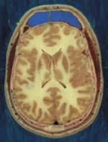

**Executive Summary**

The deep learning that implemented on Jetson Tx2 does not only classify the image as source, it also has ability to use the camera to perform the real time classification. Moreover, by adapting the well-trained model to another functionality, the Jetson Tx2 can finish tasks such as face detection and human body movement detection. ECE 480 Design Team fifteen will provide solution that implements all the works on this new technology platform. The system interacts with Tx2 development kit, one external camera and other components. The final cost of the project is less than $150.

Circuits, Systems and Artificial Neural Networks Laboratory is a distinguished lab in the Department of Electrical Engineering at Michigan State University. It is a leading place where focusing on all technologies that are at the forefront of the time. They design and implement artificial neural network algorithms in VLSI. The main research aspects around this lab are neuroscience, dynamical system theory, control systems and circuits.

**Acknowledgements**

On behalf of ECE 480 Design Team Fifteen, we would like to thank the following people that have helped us in succeeding to achieve our goals for this project:

Our sponsors from The Circuits, Systems, And Neural Networks lab (CSANN), not only for providing the funding which allowed us to research this project, but also for technical support that provides us a great opportunity to study the deep learning that helps us exploring more knowledge in our future education.

Our facilitator, Dr. Fathi Salem, for the patient guidance, encouragement, advice and support he provided that has solved many issues that we have come across. We are very honor and lucky to have a facilitator who cares so much about our work, and who responds our questions and queries promptly.

Our senior design instructors, Dr. John Albrecht and Dr. Dean Aslam, for their organization of this course and their guidance that solved issues that the team have come across. We are pleasuring to participate their course that helps us to assess ourselves clearly which will benefit our future career life.

Table of Contents

Chapter 1 – Introduction 7

1.1 Deep Neural networks for Image/video Recognition and Classification 7

1.2 Potential for Neural Networks Deep Learning 7

Chapter 2 – Exploring Solutions and Final Approach 8

2.1 NVidia Jetson Tx2 8

The Jetson TX2 is an embedded artificial intelligence super computing platform based on NVIDIA Pascal™ architecture. It has some powerful features: the enormous computing speed, a small shape (roughly the same size as an ITX motherboard), and high Energy efficiency. These features make the Jetson TX2 able to assemble into intelligent terminal equipment, such as robots, drones and portable medical equipment. As a second-generation platform, the Jetson TX2 can perform all the function the TX1 module has and be able to build more complicated deep neural network. 8

2.2 Host Desktop Building Approach 8

a. GPU 9

b. CPU 9

c. Memory stick 9

d. Solid State Drive: 10

e. Heat dissipation: 10

2.3 Project Flow Chart 11

2.4 Budget 12

2.5 Gantt Graph 14

Chapter 3 – Technical Description of work performed 15

3.1 System Setup 15

3.1.1 Required hardware 15

3.1.2 Required software 15

3.1.3 Installing operating system on the Host 15

3.1.4 Installing JetPack on the Host and flashing Jetson 16

3.1.5 Setting up DIGITS on the host 16

3.1.6 Installing NVcaffe on the host 17

3.1.7 Installing DIGITS on the host 18

3.1.8 Building from source on Jetson TX2 19

3.1.9 Classifying Images with ImageNet 20

3.2 Working on ImageNet ILSVRC12 dataset 22

3.2.1 Downloading ILSVRC12 dataset 23

3.2.2 Reorganizing the Classes 24

3.2.3 Importing 10classes dataset into DIGITS server 25

3.2.4 Creating Image Classification Model on DIGITS server 27

3.2.5 Testing 10classes on DIGITS 28

3.2.6 Reorganized 10classes dataset and created new model on DIGITS 30

3.2.7 Retesting 10classesII on DIGITS 32

3.3 Working on MNIST dataset 32

3.3.1 Downloading the MNIST dataset 33

3.3.2 Importing MNIST dataset into DIGITS server 34

3.3.3 Creating MNIST Model on DIGITS server 35

3.3.4 Testing model MNISTMD 36

3.3.5 Fine-tuning MNIST using DIGITS 38

3.3.6 Modifying and creating network on MNIST 38

3.3.7 Testing model fine-tuning MNISTMD 40

3.3.8 Reorganizing MNIST to new odd_even dataset and create model on DIGITS 40

3.3.9 Creating model of fine-tuning odd_even 42

3.3.10 Testing odd_even model from LeNet and model from fine-tuning 44

3.4 Encountered problems and solutions 45

3.4.1 Problems and solutions for setting up host pc 45

3.4.2 Problems and solutions for flashing Jetson 46

3.4.3 Problems and solutions for installing software 46

3.4.4 Problems and solutions for reorganizing classes 46

Chapter 4 - Test data with proof of functional design 48

4.1 Using images to test 10classesII and default GoogleNet on Jetson 48

4.2 Using camera to test 10classesII and default GoogleNet on Jetson 51

4.3 Testing LeNet and fine-tuning models of MNISTMD. 53

4.4 Testing LeNet and fine-tuning models of oddeven. 55

Chapter 5 – Summary and Conclusion 56

5.1 Summary 56

5.2 Lessons Learned 57

5.3 Further Improvements 57

Appendix 1 – Technical roles, responsibilities, and work accomplished. 59

Team Photo 59

Jiaxu Zhao 59

Shuotao Wang 60

Yu Han 60

Appendix 2 – Literature and website references 61

Appendix 3 – Detailed technical attachments 63

**Parts list** 63

**Source code list** 66

LeNet 66

Fine-tuning LeNet 67

# Chapter 1 – Introduction

## Deep Neural networks for Image/video Recognition and Classification

Team’s task is to efficiently implement these models onto the smart device or on an attached embedded platform (e.g., attached custom PCB-board with power and communication via the USB i/o). The final project will include demos of the accuracy performance in recognition and classification of the device captured images. The team’s project outcomes will be judged on ability to satisfy several competing performance metrics: classification or prediction (accuracy) performance, execution speed and added power consumption expense.

## Potential for Neural Networks Deep Learning

Although the general conception of Neural Networks has been created for more than twenty years. There is still a long way to achieve the real active “thinking”. For example, in the case of computer vision, it is still hardly to identify the comprehensive scenes or confusing images. However, the secular upheaval of develop progression does not meaning that the deep learning is not worth to explore. Indeed, for or some of aspect as ordinary people concern, it is not worthwhile to spend time on such kinds of researching, or invest a lot of focus in order to achieve some visual ability, which may even not as good as children's ability. Although these networks require a large amount of computation to complete an image recognition and classification that human can easily accomplish, the biggest advantage of machine learning are parallelized processing and mass-promote ability. By using the well-trained model, human can easily hand over the work to the artificial intelligence with barely cost. This is the real potential value of deep learning and this is the reason that the world's leading companies and governments are keen on this.

# Chapter 2 – Exploring Solutions and Final Approach

## 2.1 NVidia Jetson Tx2

## The Jetson TX2 is an embedded artificial intelligence super computing platform based on NVIDIA Pascal™ architecture. It has some powerful features: the enormous computing speed, a small shape (roughly the same size as an ITX motherboard), and high Energy efficiency. These features make the Jetson TX2 able to assemble into intelligent terminal equipment, such as robots, drones and portable medical equipment. As a second-generation platform, the Jetson TX2 can perform all the function the TX1 module has and be able to build more complicated deep neural network.

Jetson TX2 contains a six-core CPU, 4 Cortex-A57 and two Denver cores developed by NVidia Company. The GPU inside is based on Pascal structure. The GPU contains 256 CUDA core, supplied with 8GB 128bit LPDDR4 memory. The operating bandwidth can up to 58.4GB/s, two times larger than that in TX1 (Which is 25.6GB/s), the eMMC flash memory is upgraded from 16 GB to 32GB.

According to NVidia, Jetson TX2 have two operating modes. The first mode is MAX Q, the Jetson TX2 can perform can perform high Energy efficiency ratio in this mode, 2 times efficient than TX1. User can use another mode when doing complicated calculations, which is the MAX P mode. The TX2 can perform its highest operation speed while keep the power consumption under 15watts.

## 2.2 Host Desktop Building Approach

Due to the needs of this project, deep learning requires training of model that will be inferenced on Tx2. To configure deep learning, the host PC need to satisfy the requirements of CPU, GPU, memory stick, SSD, power supply, cooling, chassis, motherboard, etc. The following is a detailed interpretation about how each part will affect the performance of deep learning and how the team choose the components and build up this host.

### GPU

The image processing unit acts as a parallel processor that is originally used to process images. However, due to the increasing of big data, it has been widely used in many fields, including "deep learning", "smart driving" and "VR". It can use multiple threads for high-speed matrix operations, and deep learning involves many matrix operations. So choosing a suitable GPU becomes critical. The GPUs that are commonly used in deep learning include GTX960, GTX970, GTX1080, TiTan x, GTX1080Ti, etc. The above GPUs belong to the GeForce series and perform "single floating point operation". These are some relatively new model with strong performance. The most important change is in the architecture and SM (number of threads). The team decides to build host with a GTX970, which is Maxwell architecture. It properly met the requirement of the training that this project will used. Another reason that the team decide to use GTX970 is the cost of project. One of the team member replaces his GTX970 with another graphic card which provide to host PC.

### CPU

For deep learning, the requirements of CPU are not particularly high. A relatively strong CPU can save part of the cost while having similar performance compared to a high-end CPU. As a high-speed serial processor, it is commonly used as a controller to send and receive instructions or parsing instructions. Due to the limitations of the internal structure of the GPU, it is more suitable for high-speed parallel computing, not suitable for fast instruction control. Moreover, many data needs to be accessed between the GPU and the CPU during the model training. Those are the two parts that CPU take response due to its better performance.

### Memory stick

It exchanges data between CPU and peripherals. It is much faster than hard disk to access files. In deep learning, many data exchange operations are involved (for example, reading data by batch). One of the solution is to store the data on the hard disk and read small batch size for each time. However, the training cycle will be very long. Another common solution is to select a large memory and read data from several batches from the hard disk and store it in memory, and then perform data processing. This ensures that the data transfer is uninterrupted, which makes data processing more efficient. The team chooses to use 8GB memory. Because the memory size is better to be larger than the memory of GPU. Usually the larger memory will show its advantages when training a larger model. However, according to project description and researching, the biggest dataset that the host will use to train during a single time is up to 100GB so that the 8GM memory is satisfied.

### Solid State Drive:

As a local storage for dataset and models. In deep learning, the hard disk can be used to save layers code, network, framework, models, intermediate results and data sets. It is recommended to choose a large capacity hard disk because the general data that will be used in deep learning is usually larger than 100GB. While deep learning itself is based on "big data", it requires a lot of data to get better performance. Based on data size. The team split 512GB SSD for project operations, including OS system, package, data, models, etc.

### Heat dissipation:

Since the operation on host PC generates a lot of heat and each electronic component has an acceptable temperature range, temperature that too high usually causes the components to be in a unusual working state, resulting degrading performance in the host PC. Due to the large amount of computation required for deep learning, it usually takes tens or hundreds of hours for training. During this period, to ensure the normal operation of the components, the corresponding level of heat dissipation measures are required. This will not only ensure the efficiency of the host, but also extend the life of the host.

There are three main types of commonly used heat dissipation measures:

1) Add a heat sink. It is usually made of aluminum or copper and is usually mounted around or on CPU or GPU. Copper products usually have better heat dissipation.

2) Add a cooling fan. Nowadays, every desktop or laptop computer may have one or more fans for fan heat. It is an very efficient way to cool down the host but it will generate large noise due to the limitation of fan.

3) Add water cooling. It is usually used on high-end host. It not only has a good cooling effect, but basically has no noise. But the price will be higher. If the host is configured with multiple GPUs, it is highly recommended that configure water cooling, which will keep device running at high speed.

## 2.3 Project Flow Chart

The flow chart shown in following demonstrates how the team members attempted to build this project with provided platform. The first step is to acquire data from either internet or camera stream. The size of data should be large enough to support the training process. Thus, we download some provided training data from open source website, which contains varies classes of pictures. Then the team needs to manage all data that we get from internet or capture my ourselves. For example, the data need to be divided into different index with certain label. Then the team needs to create dataset by using these sorted resources. Then the network and some setting need to be determined before training. After created dataset, the longest process, which is model training, will start on host PC. When the model becomes well-trained, it will be uploaded to Jetson Tx2 which the final inference will be performed. And the test result should be showed up at the end of project, which is classification with high accuracy.

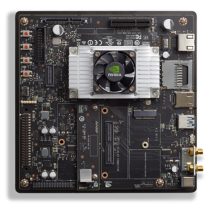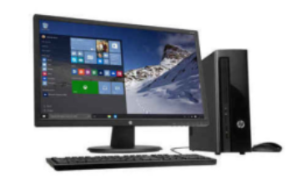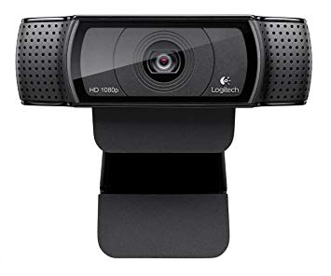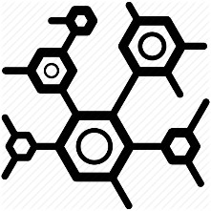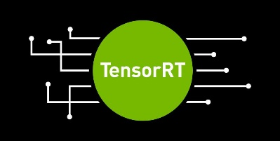

Image/video

TRANING

VALIDATION

Model

Classified Result

## 2.4 Budget

At the beginning of this project, the group was handed a $500 budget to spend on any resources that the group might use to finish this project. To reduce the cost of project, team members discussed a lot about platform that will be used. The initial design is a Raspberry Pi because the computation of it has met the requirement of project description. However, after we first met our sponsor, a Jetson Tx2 was provided to the team. After we explored this platform, we realized that Tx2 is a perfect platform to perform deep leaning. The size of this development kit can be placed on a fixed board. And the power consumption of e kit is acceptable since the project may requires hundreds of hours to train models. And this development kit is reusable so that we can return to sponsor when we finish our design project. Good budget planning was essential to giving the team room to invest and test different methods of finishing this project. This team was still able to finish the project under the $500 budget and still have leftover. The expenses of this team are fully detailed in the below table.

|  |  |  |  |  |
| --- | --- | --- | --- | --- |
| Component | Quantity | Cost | Shipping | Total |
| Wireless keyboard and mouse | 1 | 24.99 | 0 | 24.99 |
| Logitech C920 | 1 | 49.99 | 0 | 49.99 |
| USB hub | 1 | 19.99 | 0 | 19.99 |
| Ethernet to USB adapter | 1 | 24.99 | 0 | 24.99 |
| Total |  |  |  | 119.41 |

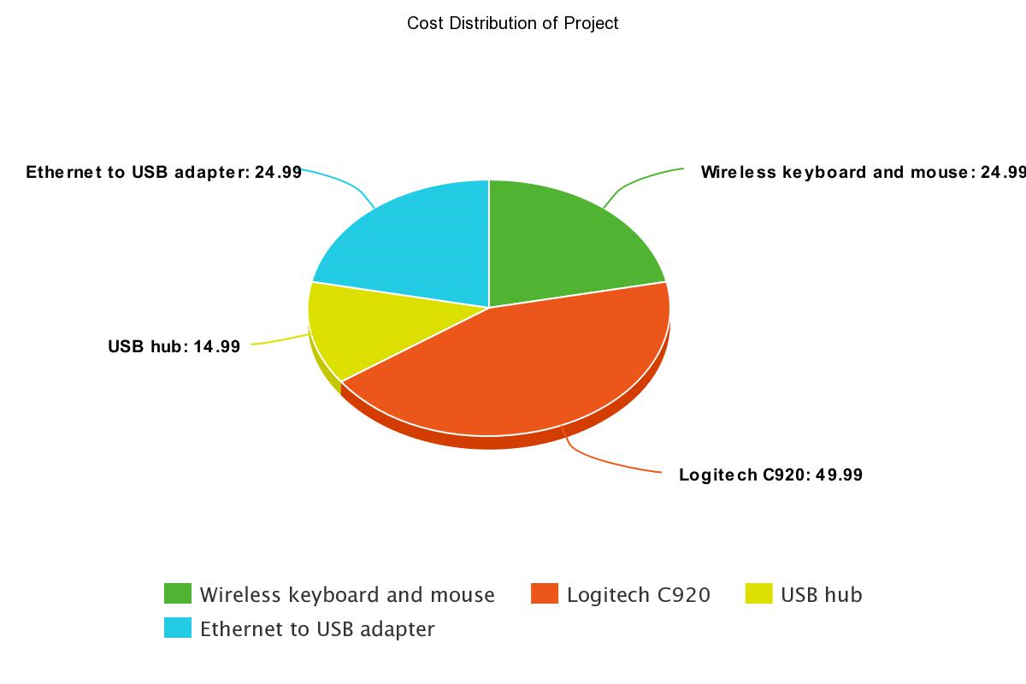 Distribution of Cost

## 2.5 Gantt Graph

Following graph is the Gantt chart for design team fifteen. Member of team realizes that being on time is just as important as being under budget and being resourceful. From this Gantt chart the team wanted to first define the project task. From there on the team moved on to install external component, OS build, sample test, camera test, choose framework, create dataset, create model, training model, validate model and create inference. The Gantt chart listed dates on when a goal would be started and when it should be accomplished. The design team followed this schedule strictly and had all these tasks done on time.

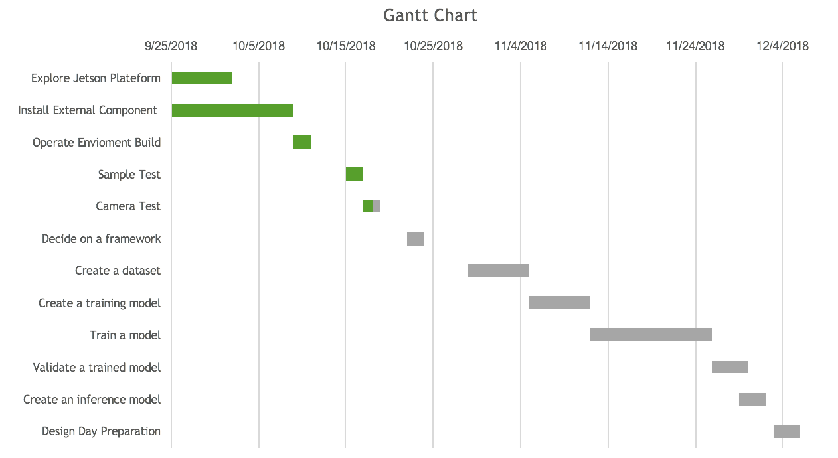

# Chapter 3 – Technical Description of work performed

## 3.1 System Setup

### 3.1.1 Required hardware

For this project, the team uses a desktop pc with I5 CPU + GTX970 + 8 GB memory + 512 GB SSD as the host. It is required to have a laptop or desktop (preferred) with powerful NVIDIA video card because of the massive number of dependencies required for training such as GTX 1080, TiTan x or better if the funding is enough and a HDMI monitor. Alternate, if there are difficulties to have the required hardware, it is recommended using NVIDIA GPU Cloud (NGC) to setup the host pc. NGC automates the install of the drivers and required frameworks on the host. A host pc is used for training deep neural networks and also serve to flash the Jetson TX2 with the latest JetPack.

### 3.1.2 Required software

CUDA Toolkit (NVIDIA Compute Unified Device Architecture)

cuDNN (NVIDIA CUDA Deep Neural Network library)

NVcaffe (NVIDIA branch of Caffe with optimizations for GPU)

DIGITS (NVIDIA Deep Learning GPU Training System)

### 3.1.3 Installing operating system on the Host

Recommended system requirements are 2GHz dual core processor or better, 2 GB memory, 150 GB of free hard drive space, at least 8GB USB drive for the installer and internet access. Download the installer of Ubuntu 16.04.5 Desktop (64-bit) from following location.

<https://www.ubuntu.com/download/alternative-downloads>

### 3.1.4 Installing JetPack on the Host and flashing Jetson

Download the latest JetPack to the host pc from <https://developer.nvidia.com/embedded/jetpack>.

After downloading, run it from the host PC using terminal with following commands:

**$ cd <directory where you downloaded JetPack>**

**$ chmod +x JetPack-L4T-<version>-linux-x64.run**

**$ ./JetPack-L4T-<version>-linux-x64.run**

The JetPack GUI will pop up and follow the step-by step installation instructions below for the full directions for installing and flashing the Jetson with the latest Jetpack.

<https://docs.nvidia.com/jetson/archives/jetpack-archived/jetpack-33/index.html#jetpack/3.3/install.htm%3FTocPath%3D_____3>

### 3.1.5 Setting up DIGITS on the host

The team set up DIGITS natively on the host pc instead using NVIDIA GPU Cloud (NGC). The JetPack has already installed CUDA toolkit on the host, the NVDIA PCle driver is needed to enable GPU-accelerated training. Run the following commands to install the driver:

**$ sudo apt-get install nvidia-384**

**$ sudo reboot**

After rebooting, run **$ lsmod | grep nvidia**, if the NVIDIA driver is successfully installed, the information will be listed like this:

nvidia_drm 40960 1

nvidia_modeset 1044480 2 nvidia_drm

nvidia 16793600 73 nvidia_modeset

drm_kms_helper 172032 1 nvidia_drm

drm 401408 4 drm_kms_helper,nvidia_drm

ipmi_msghandler 53248 2 ipmi_devintf,nvidia

In order to verify the CUDA toolkit and NVIDIA driver are working correctly, run some tests by typing following commands:

**$ cd /usr/local/cuda/samples**

**$ sudo make**

**$ cd bin/x86_64/linux/release/**

**$ ./deviceQuery**

**$ ./bandwidthTest --memory=pinned**

### 3.1.6 Installing NVcaffe on the host

NVcaffe requires cuDNN and is used by DIGITS for training DNNS, run following commands to clone the repository of caffe-0.15:

**$ git clone -b caffe-0.15 https://github.com/NVIDIA/caffe**

Build Caffe with instruction from <http://caffe.berkeleyvision.org/installation.html#compilation>

After building, edit the ~/.bashrc file to add the following path to the Caffe.

**export CAFFE_ROOT=/home/abc/Desktop/caffe**

**export PYTHONPATH=/home/abc/Desktop/caffe/python:$PYTHONPATH**

Close the terminal and reopen it.

### 3.1.7 Installing DIGITS on the host

NVIDIA DIGITS is a front-end tool with GUI for developing, training and visualizing deep neural networks and manages datasets and networks. First, Clone the DIGITS repository:

**$ git clone https://github.com/nvidia/DIGITS**

Then follow the steps in BuildDigits.md: <https://github.com/NVIDIA/DIGITS/blob/digits-6.0/docs/BuildDigits.md>

To start the webserver, at DIGITS directory run **$ ./digits-devserver**, if the DIGITS is successfully installed and compiled, the terminal will look like this:

___ ___ ___ ___ _____ ___

| \_ _/ __|_ _|_ _/ __|

| |) | | (_ || | | | \__ \

|___/___\___|___| |_| |___/ 6.1.1

2018-12-02 13:30:37 [INFO ] Loaded 16 jobs.

Open the browser and enter the address "localhost:5000" to access the graphical web interface of DIGITS. The page will look like this:

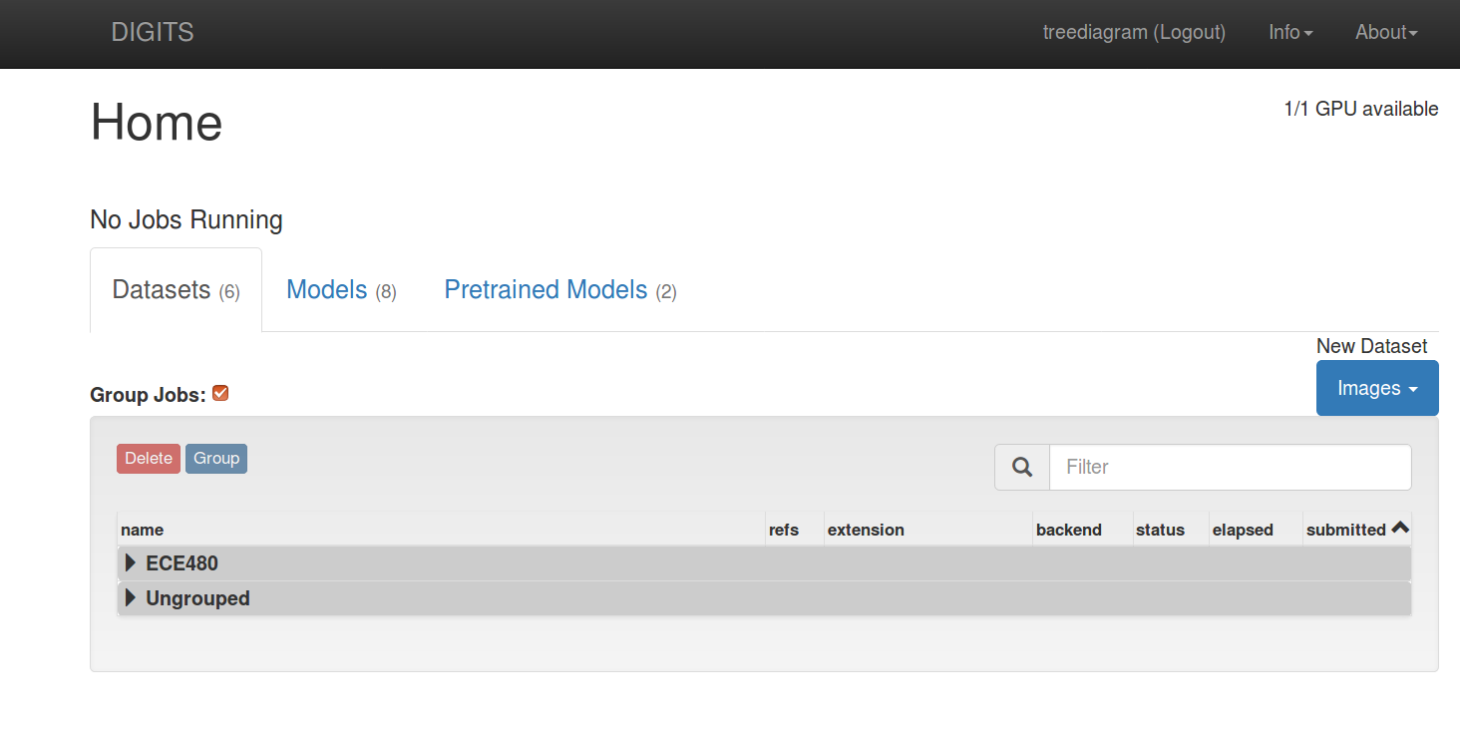

### 3.1.8 Building from source on Jetson TX2

The team uses a public source on Github that is a training guide for inference and deep vision runtime library for NVIDIA DIGITS and Jetson TX2. The repository uses NVIDIA TensorRT to efficiently deploy neural networks to embedded platforms, using graph optimization, kernel fusion and half-precision FP16 to improve performance and power efficiency on the Jetson. There are some visual primitives, such as imageNet for image recognition, detectNet for object detection, and segNet for segmentation.

<https://github.com/dusty-nv/jetson-inference#building-from-source-on-jetson>

Make sure the CMake and git are installed and then clone the repository:

**$ sudo apt-get install git cmake**

**$ git clone https://github.com/dusty-nv/jetson-inference**

**$ cd jetson-inference**

**$ git submodule update --init**

Configuring with Cmake and compiling the project:

**$ mkdir build**

**$ cd build**

**$ cmake ../**

**$ make**

### 3.1.9 Classifying Images with ImageNet

ImageNet has been trained to identify similar objects for image recognition and classification.

The class of the classified object and confidence of the classified object are printed to the top left. By default, the application can recognize up to 1000 different types of objects, since GoogleNet and AlexNet are trained on the ILSVRC12 ImageNet database which contains 1000 classes of objects. ILSVRC12 stands for Large Scale Visual Recognition Challenge 2012.

<http://www.image-net.org/challenges/LSVRC/2012/>

Using the console program on Jetson for classifying, after building, change the directory:

**$ cd jetson-inference/build/aarch64/bin**

Then, run the imagenet-console for classifying a single image downloaded from internet, the accuracy and classification are printed on the top left of the output image:

**$ ./imagenet-console car..png output_0.jpg** 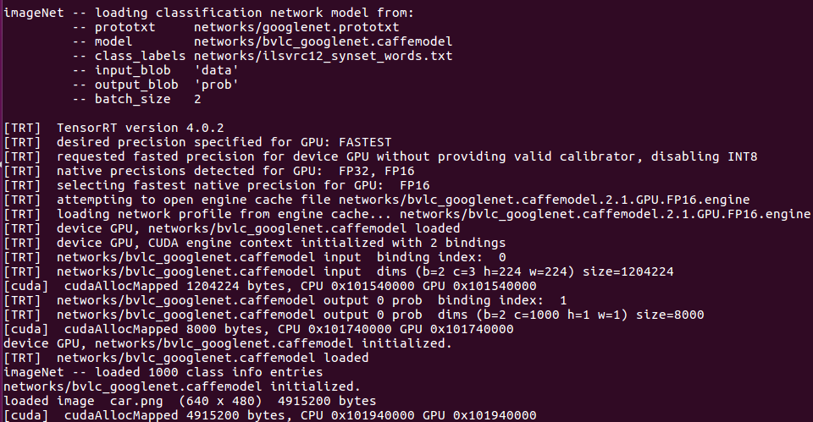

The console shows that the Jetson is running TensorRT to load bvlc_GoogleNet caffe model to inference and the result of classification and its confidence shows below:



The image is classified to sports car with 77.627% accuracy.

Running the live camera recognition:

imagenet-camera is a program for the real-time image recognition that runs on live camera stream and depending on the arguments, loads GoogleNet or AlexNet or another self-trained network with TensorRT.

**$ ./imagenet-camera GoogleNet to load GoogleNet caffemodel**

**$ ./imagenet-camera AlexNet to load AlexNet caffemodel**

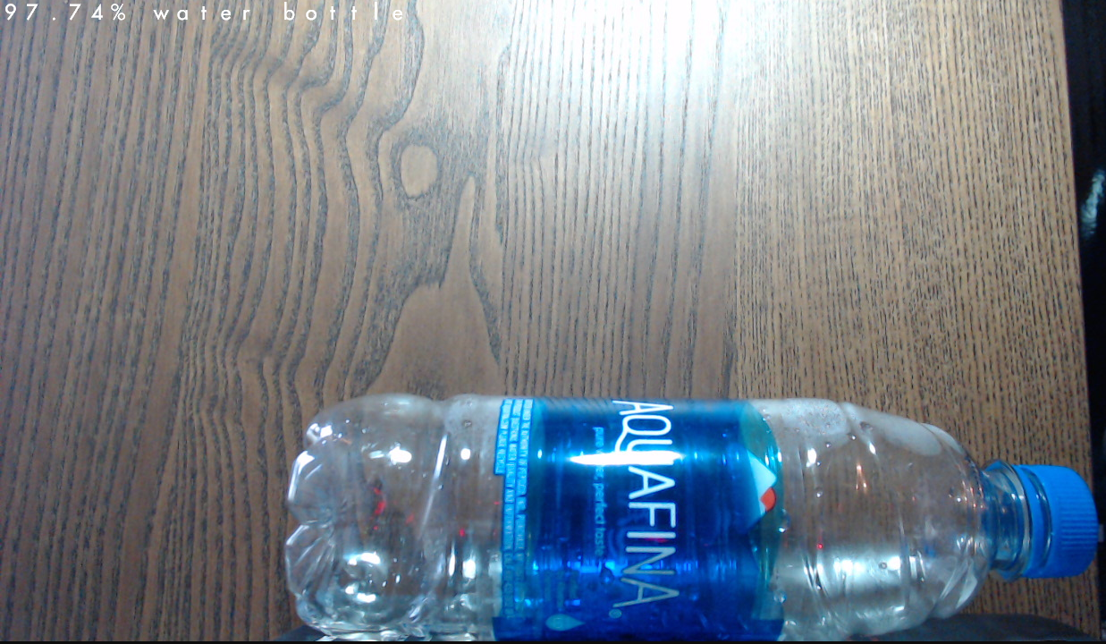

The object is captured by the live camera and is classified to water bottle with 97.74% accuracy.

## 3.2 Working on ImageNet ILSVRC12 dataset

The existing GoogleNet and AlexNet models that are downloaded by the repo are pre-trained on 1000 classes of objects from the ImageNet ILSVRC12 benchmark. To recognize a new object class, the network can be re-trained using DIGITS on new data. For this project, the team decides to reorganize the existing classes, groups multiple subclasses into one parent class. The team takes 113 of the 1000 classes, group those into 10 classes and retrain the network.

### 3.2.1 Downloading ILSVRC12 dataset

The ILSVRC12 dataset is about 100GB and includes 1,000,000 images with more than 1,000 classes. This dataset is used to train the default GoogleNet and AlexNet models. Make sure the host has over 120 GB free disk on home section of Ubuntu to store the dataset. There is a file named "imagenet-download.py" to download the dataset by running the following commands:

**$ wget --no-check-certificate https://nvidia.box.com/shared/static/gzr5iewf5aouhc5exhp3higw6lzhcysj.gz -O ilsvrc12_urls.tar.gz**

**$ tar -xzvf ilsvrc12_urls.tar.gz**

**$ wget https://rawgit.com/dusty-nv/jetson-inference/master/tools/imagenet-download.py**

**$ python imagenet-download.py ilsvrc12_urls.txt . --jobs 100 --retry 3 --sleep 0**

This download takes roughly 12 hours. With over 1,000 different classes, each single class is stored in its own directory with 8-digit ID that can be identified to its name of the class.

n01440764/

n01443537/

n01484850/

n01491361/

n01494475/

...

The whole identification for 1,000 classes can be checked in the "ilsvrc12_synset_words.txt", for example, the directory with ID n01440764 refers to tench, Tinca tinca.

### 3.2.2 Reorganizing the Classes

The team decides to reorganize the data based on the real life. The 10 classes are furniture with 10 subclasses, electronic device with 12 subclasses, fruit with 12 subclasses, vehicle with 14 subclasses, bottle with 10 subclasses, bird with 12 subclasses, cloth with 12 subclasses, sports equipment with 11 subclasses, stationery and shop with both 10 subclasses.

sport_equipment/ (12)

/baseball (→n02799071)

/basketball (→n02802426)

/soccer ball (→n04254680)

/tennis ball (→n04409515)

/...

These 10 core groups may be more practical to use than 1000 individual classes and combining across classes results in more training data and more accurate classification for the group. The team modified the “imagenet-subnet.sh” which is a provided script file to take the absolute path to ILSVRC12 dataset of a single class as the input and output the path to the parent class. The formal is like the following:

**DATASET_PATH=$1**

**OUTPUT_PATH=$2**

**mkdir $OUTPUT_PATH/sports equipment**

**ln -s $DATASET_PATH/n02799071 $OUTPUT_PATH/sports equipment/baseball**

run the following commands to generate the directory structure and links given the path to the ILSVRC12 dataset:

**$ wget https://rawgit.com/dusty-nv/jetson-inference/master/tools/imagenet-subset.sh**

**$ chmod +x imagenet-subset.sh**

**$ mkdir 10classes**

**$ ./imagenet-subset.sh /home/abc/Desktop/digits/classification 10classes**

The script takes the first argument as the path of stored ILSVRC12 dataset and the second argument as the output directory.

### 3.2.3 Importing 10classes dataset into DIGITS server

Open a browser and navigate to "localhost:5000" while DIGITS is running in the terminal. At Datasets tab, on the right side, choose New Dataset, Images, Classification like this: 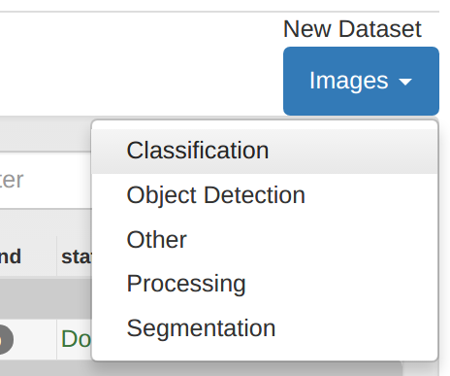

Set the path of Training Images to the 10classes folder from part 3.12 and change the setting to 10% validation and 10classes to the Dataset Name.

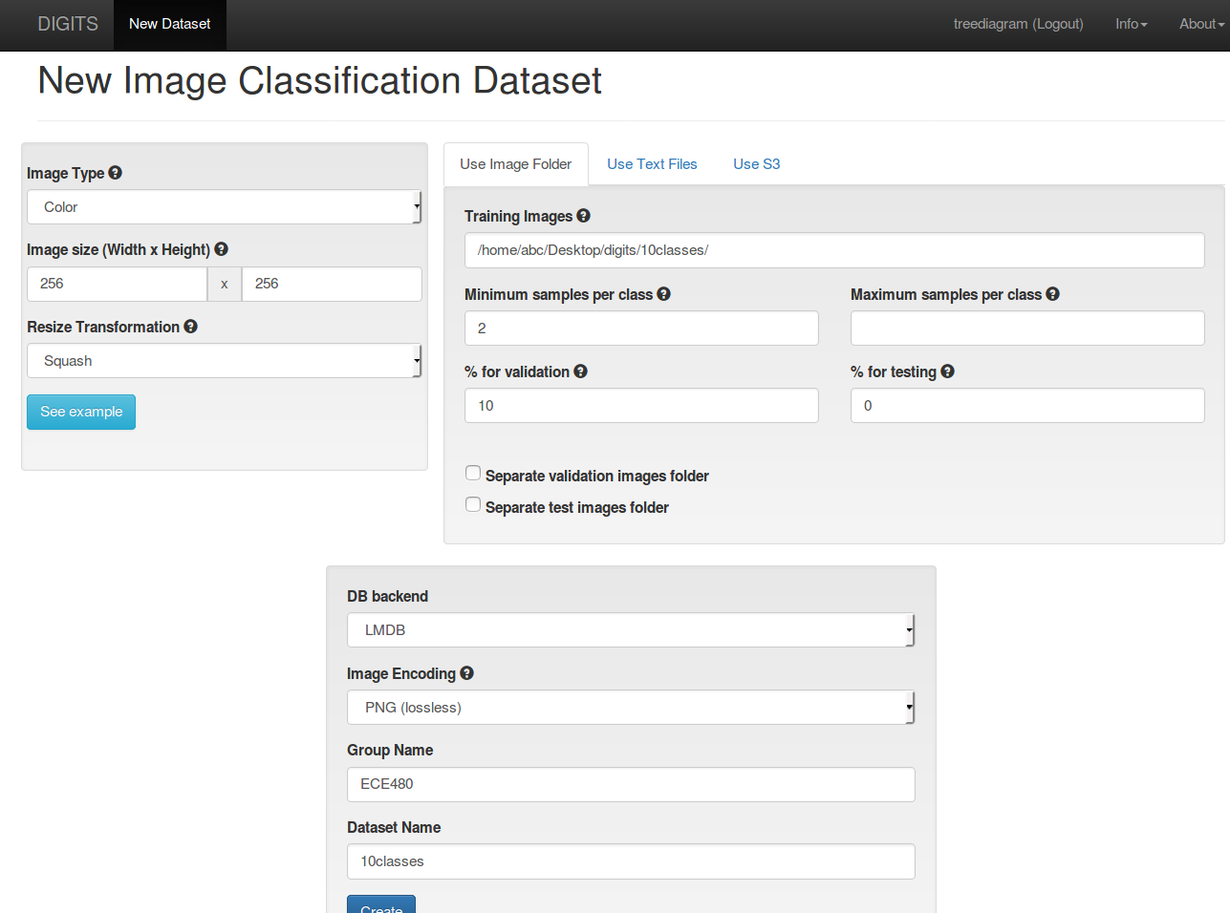

Press the create button to start importing the data, the size of the 10classes is *9.29* GB, it takes *24 minutes 45 seconds* for creating the dataset. The time consumption may vary by depending on server I/O performance.

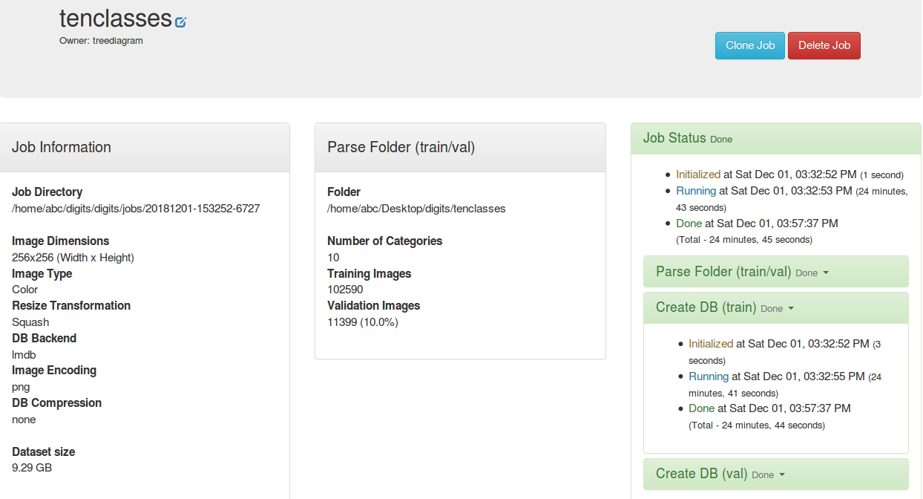

## 

### 3.2.4 Creating Image Classification Model on DIGITS server

Open a browser and navigate to "localhost:5000" while DIGITS is running in the terminal. At Models tab, on the right side, choose New Dataset, Images, Classification like this:

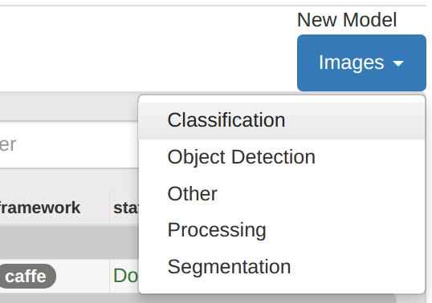

And change the settings to 10classes for Select Dataset, Pixel for Subtract Mean in Data Transformations, GoogleNet for Standard Networks, 10classes for the Model Name. After training 30 epochs, the finished model should like this:

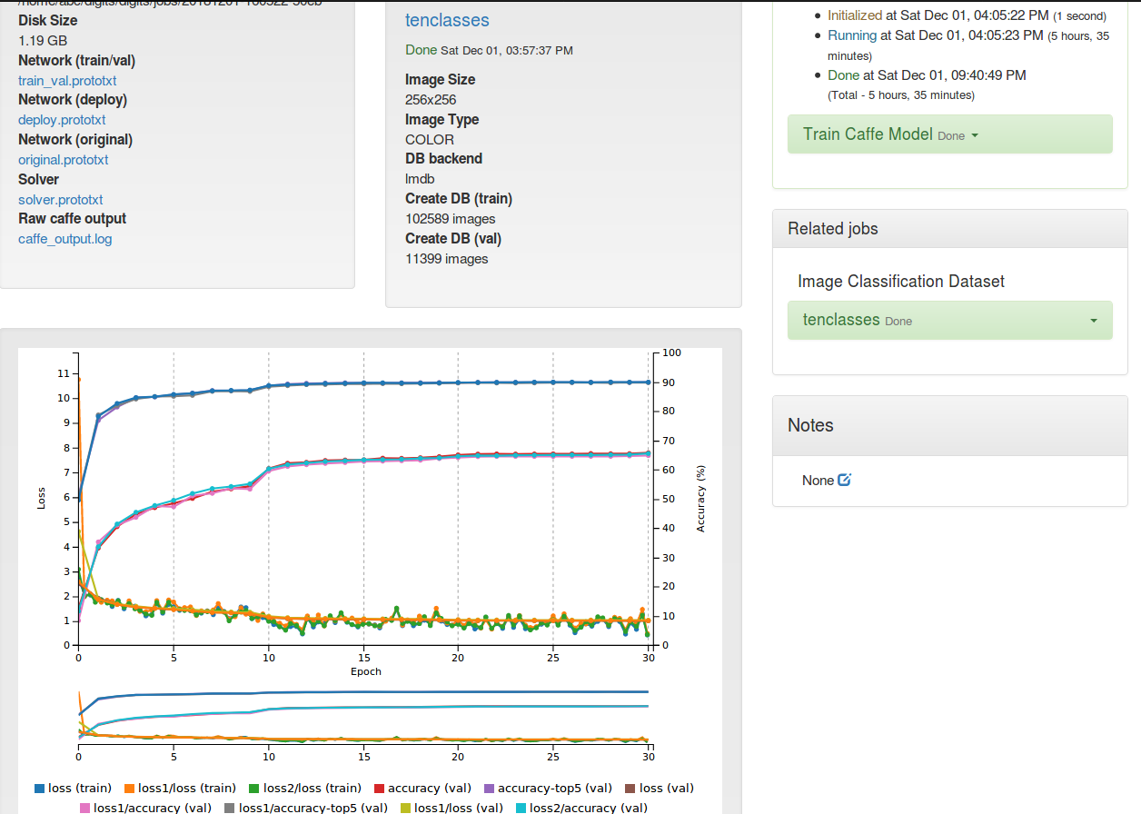

Creating model takes 5 hours and 35 minutes.

### 3.2.5 Testing 10classes on DIGITS

Try to test the accuracy of classification of the 10classes on DIGITS.

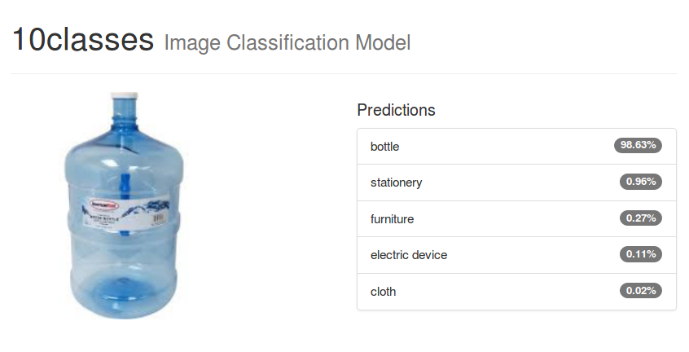

The image is classified as the new 10classes model as bottle with 98.63% accuracy, while in the original GoogleNet-1000 it was under water bottle with 51.843% accuracy. This indicates the new model is working ok for now.

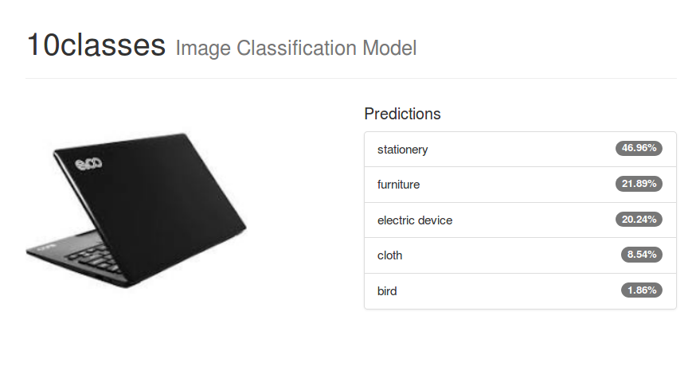

The image is classified as the new 10classes model as stationery, while in the original GoogleNet-1000 it was under notebook, notebook computer. Obviously, this is not a stationery. This indicates the new model is working seriously wrong to classify the laptop to the stationery.

### 3.2.6 Reorganized 10classes dataset and created new model on DIGITS

After digging into the subclasses, the team deleted “book” from stationery

and recreate model 10classesII, select the new dataset 10clasesII, set previous network to 10classes with 30 epoches.

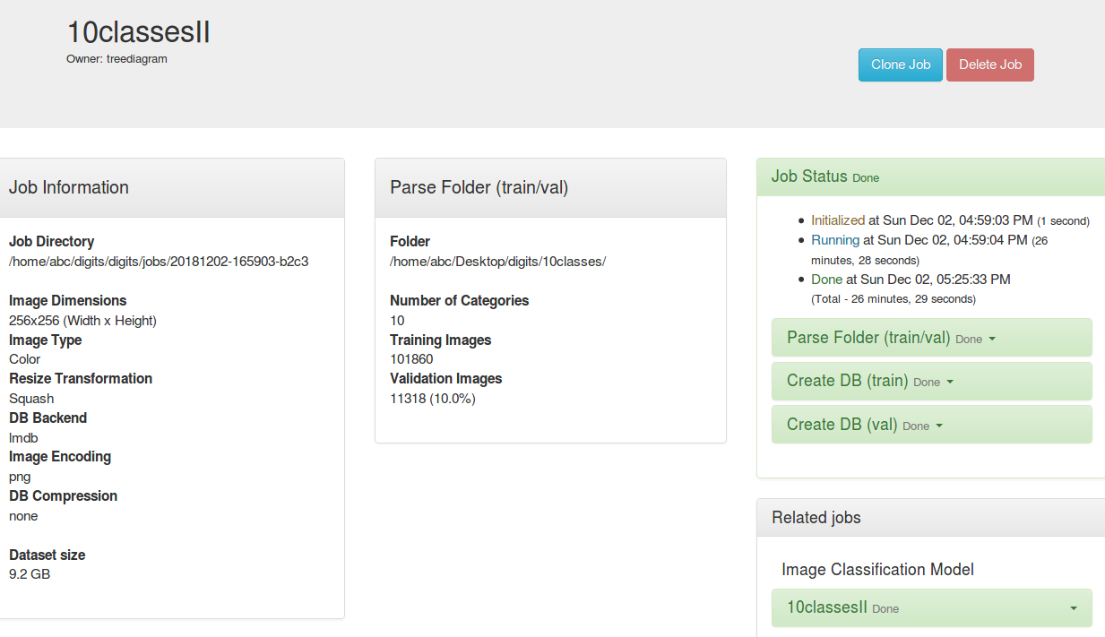

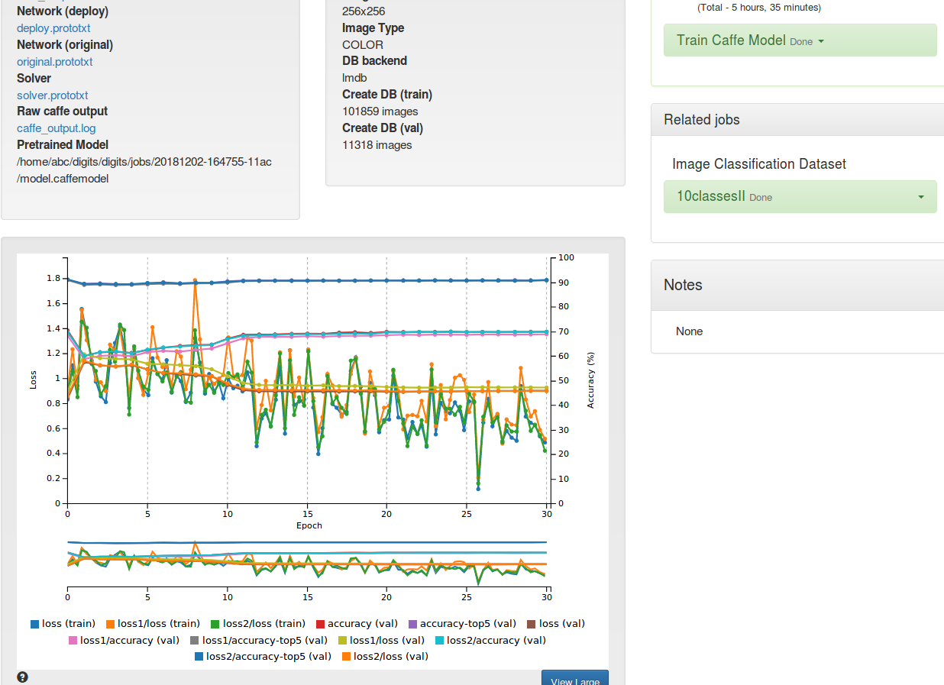

Creating new model of 10classes takes 5 hours and 35 minutes.

### 3.2.7 Retesting 10classesII on DIGITS

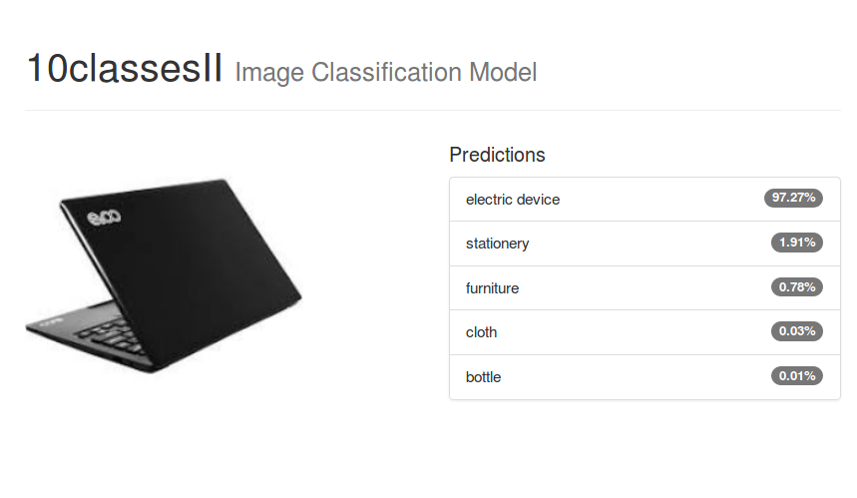

The image is successfully classified as the new 10classesII model as electronic device with 97.27% accuracy, while in the original GoogleNet-1000 it was under notebook, notebook computer. This indicates the 10classesII has fixed the issue and it is working ok.

## 3.3 Working on MNIST dataset

For this task, the team uses the MNIST handwritten digit database that is available on Yann LeCun’s website, it has 60,000 example training sets and 10,000 sample test sets. It is a subset of the larger set provided by NIST. The digits have been standardized in size and centered on fixed-size images. It is a great database for those who want to try to learn technology and pattern recognition methods on actual data while spending the least amount of preprocessing and formatting. The team uses LeNet as the network, which is known to work well on digit classification tasks. And LeNet-5 is our latest convolutional network designed for handwritten and machine-printed character recognition.

Dataset: <http://yann.lecun.com/exdb/mnist/>

LeNet: <http://yann.lecun.com/exdb/lenet/>

### 3.3.1 Downloading the MNIST dataset

Use the following commands to download the dataset into the host pc:

**$ python -m digits.download_data mnist ~/mnist**

**Downloading url=http://yann.lecun.com/exdb/mnist/train-images-idx3-ubyte.gz ...**

**Downloading url=http://yann.lecun.com/exdb/mnist/train-labels-idx1-ubyte.gz …**

**Downloading url=http://yann.lecun.com/exdb/mnist/t10k-images-idx3-ubyte.gz ...**

**Downloading url=http://yann.lecun.com/exdb/mnist/t10k-labels-idx1-ubyte.gz ...**

**Uncompressing file=train-images-idx3-ubyte.gz ...**

**Uncompressing file=train-labels-idx1-ubyte.gz ...**

**Uncompressing file=t10k-images-idx3-ubyte.gz ...**

**Uncompressing file=t10k-labels-idx1-ubyte.gz …**

**Reading labels from /home/abc/Desktop/mnist/train-labels.bin ...**

**Reading images from /home/abc/Desktop/mnist/train-images.bin ...**

**Reading labels from /home/abc/Desktop/mnist/test-labels.bin ...**

**Reading images from /home/abc/Desktop/mnist/test-images.bin ...**

**Dataset directory is created successfully at '/home/abc/Desktop/mnist'**

**Done after 16.409562739 seconds.**

### 3.3.2 Importing MNIST dataset into DIGITS server

At Training Images, type in the path to the train directory of MNIST, Image Type to Grayscale, Image size to 28 x 28, Dataset Name to MNIST and press the Create button for creating the new MNIST dataset.

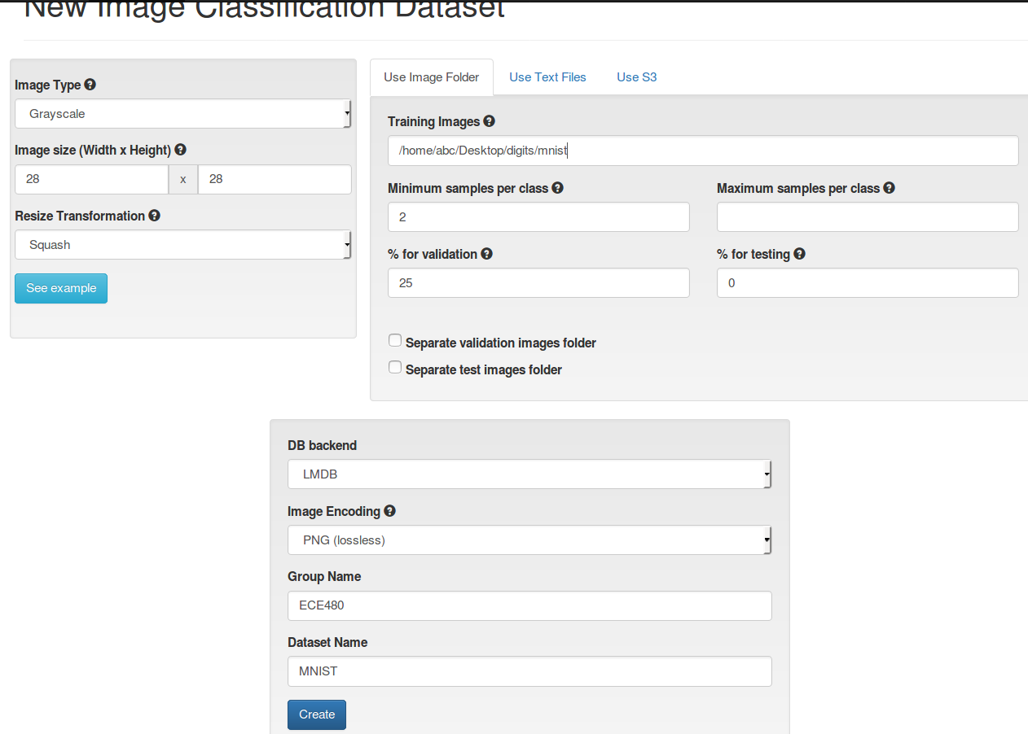

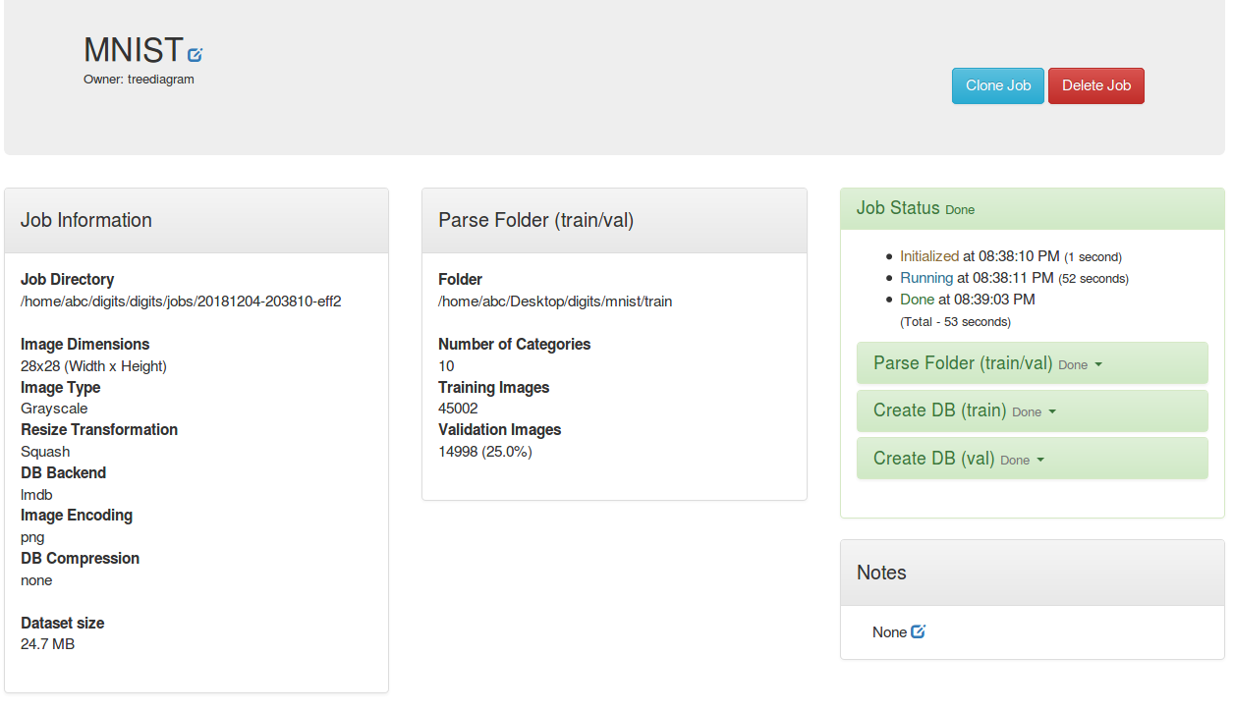



### 3.3.3 Creating MNIST Model on DIGITS server

Do the following: Select Dataset to MNIST, Standard Networks to LeNet, Model Name to MNISTMD, and press the Create button to create the model.

The time consumption of Create database for training and for validation is shown below:

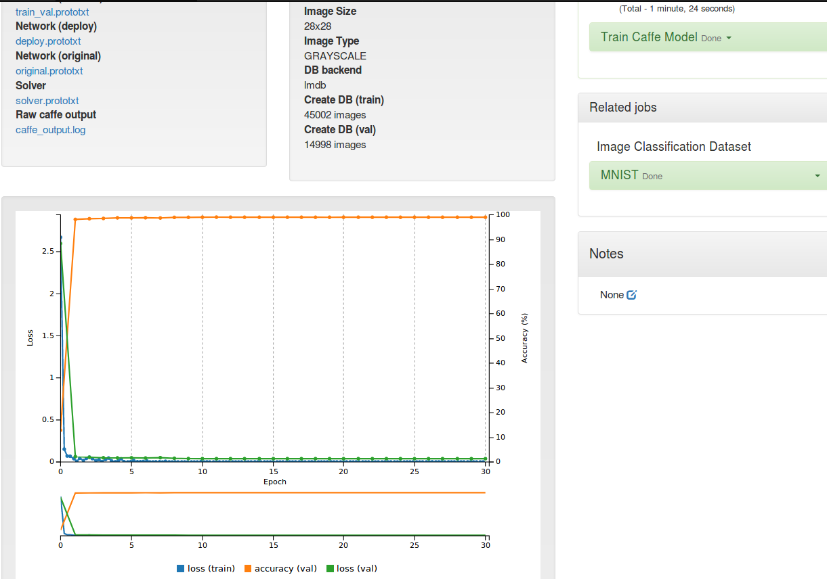

Creating model of MNIST takes 1 minutes and 24 seconds.

### 3.3.4 Testing model MNISTMD

Click the Upload image and choose an image from /home/abc/Desktop/mnist/test, press the Classify One button. DIGITS display the top-5 classifications and accuracy of each class.

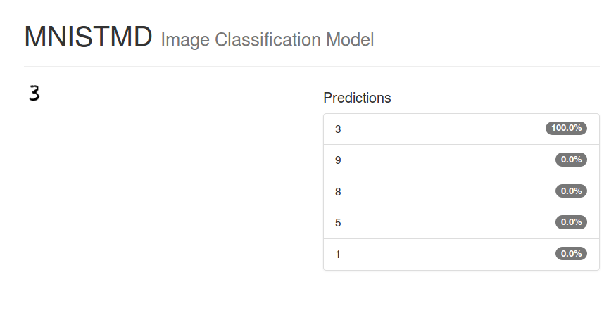

The image is classified as 3 with 100.0% accuracy.

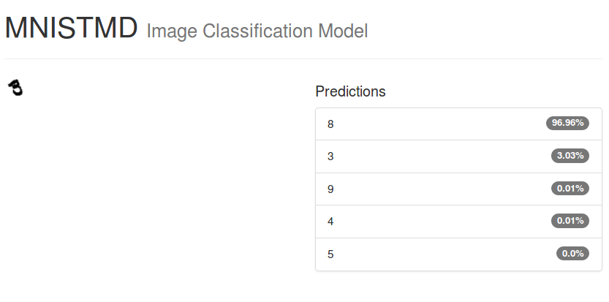

The image is classified as the 8, while in the original directory it was under 3. Obviously, this indicates the model failed to classify the image to the right class.

### 3.3.5 Fine-tuning MNIST using DIGITS

Fine-tuning the model allows the model to benefit from previously learned functionality and apply those functionalities to new tasks. This can be used to speed up training, or it can be used to train the model on a simplified dataset that would otherwise be too small to allow the neural network to learn anything. there are two ways to implement fine-tuning, one is to modify the network in order to improve performance by adding or removing a layer, pooling, modifying activation function, modifying zero padding, increasing outputs or by changing parameters only without adding layers.

### 3.3.6 Modifying and creating network on MNIST

Click Previous Networks instead Standard Networks, select MNISTMD and Pretrained Model to Epoch #30 then click Customize.

Adding to the first layer with the following parameter:

**transform_param {  
 scale: 0.00390625  
 }**

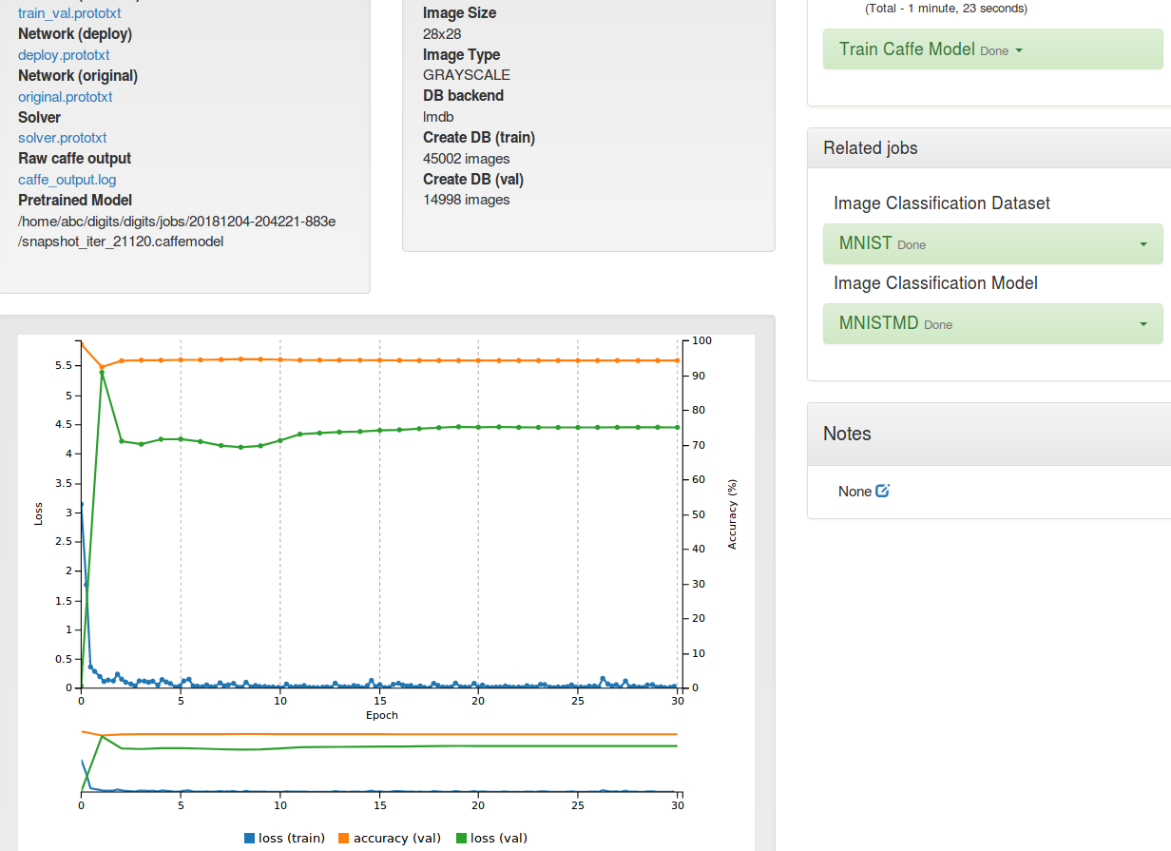

Creating for fine-tuning of MNIST takes 1 minutes 23 seconds.

## 

### 3.3.7 Testing model fine-tuning MNISTMD

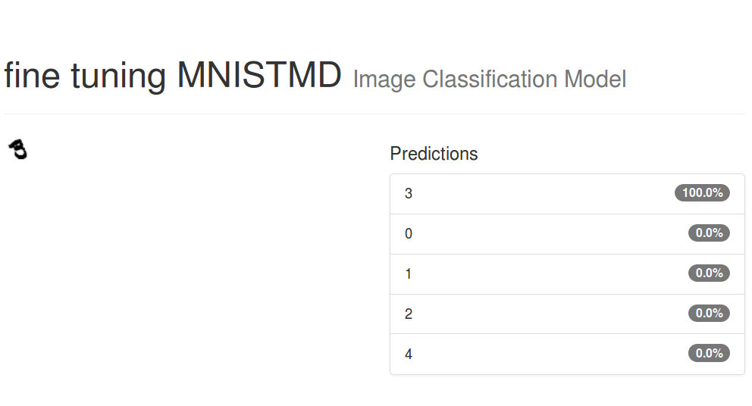

The image is successfully classified as the 3 with 100% accuracy and the default LeNet failed to classify this image. Obviously, the fine-tuning works on the new MNISTMD model.

### 3.3.8 Reorganizing MNIST to new odd_even dataset and create model on DIGITS

At the directory of MNIST, run following commands to reorganize the dataset from 10 classes into 2 classes that one is images of odd numbers and the other is images of even numbers:

**$ cd Desktop/digits/DIGITS/examples/fine-tuning**

**$ ./create_dataset.sh oddeven /home/abc/Desktop/mnist/train**

After reorganizing, in DIGITS create a new classification dataset and change settings. Image Type to Grayscale, Image Size to 28 x 28, the path to odd_or_even dataset. To illustrate the benefits of fine-tuning by reducing the amount of training samples: set the maximum samples per class to 100 and reserve 75% of samples for validation:

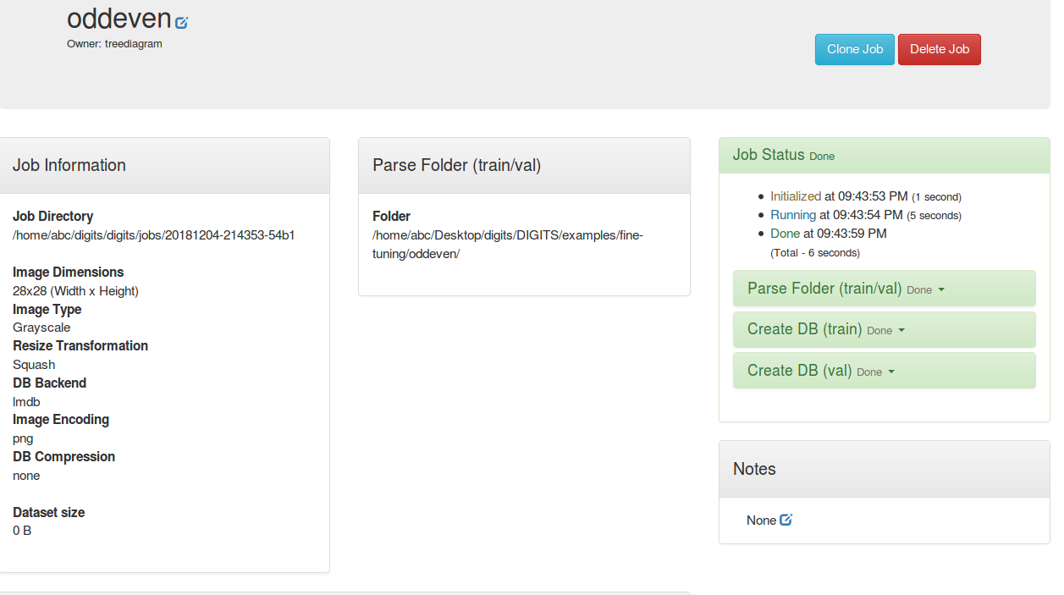

Create a model of using odd_or_even dataset from scratch by selecting LeNet

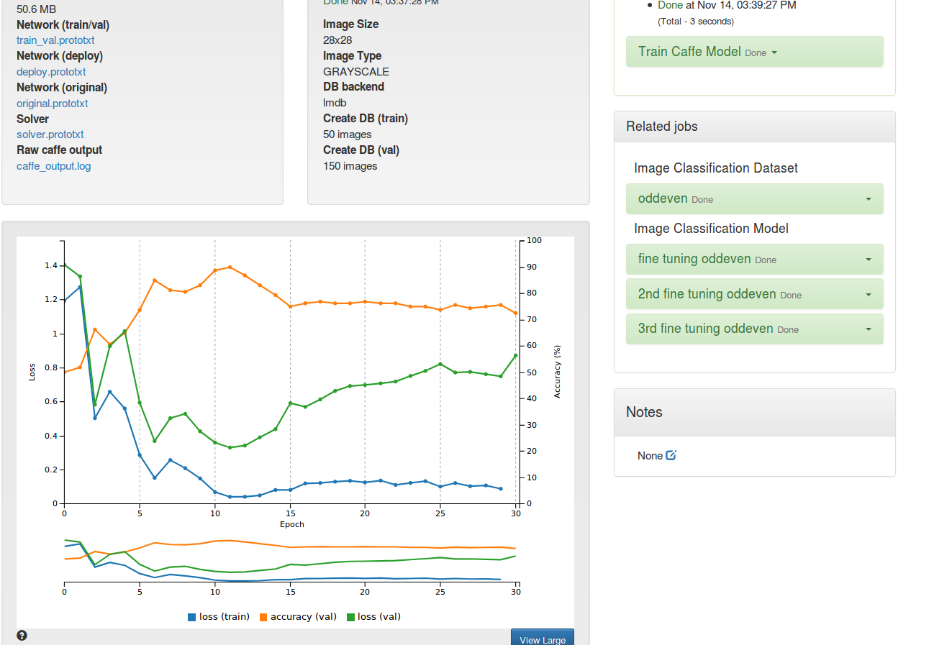

The standard LeNet model performs ok however there is a substantial amount of overfit that means the validation loss is much higher than the training loss.

### 3.3.9 Creating model of fine-tuning odd_even

**go to the image classification model page**

**select the odd_or_even_dataset**

**in the Previous networks tab, select the instance of LeNet that will be fine tuned**

**on the Pretrained model column, select the last epoch**

**click on Customize**

In the Customize area, modified the network. After fine-tuning, the network is similar to the standard LeNet except the learning rate is set to zero for the original layers in order to not change the existing features, a new InnerProduct layer with two outputs was added on top of the network and the accuracy layer is changed to compute the accuracy of the new InnerProduct layer. The visualization of fine-tuning odd_even network shows below:

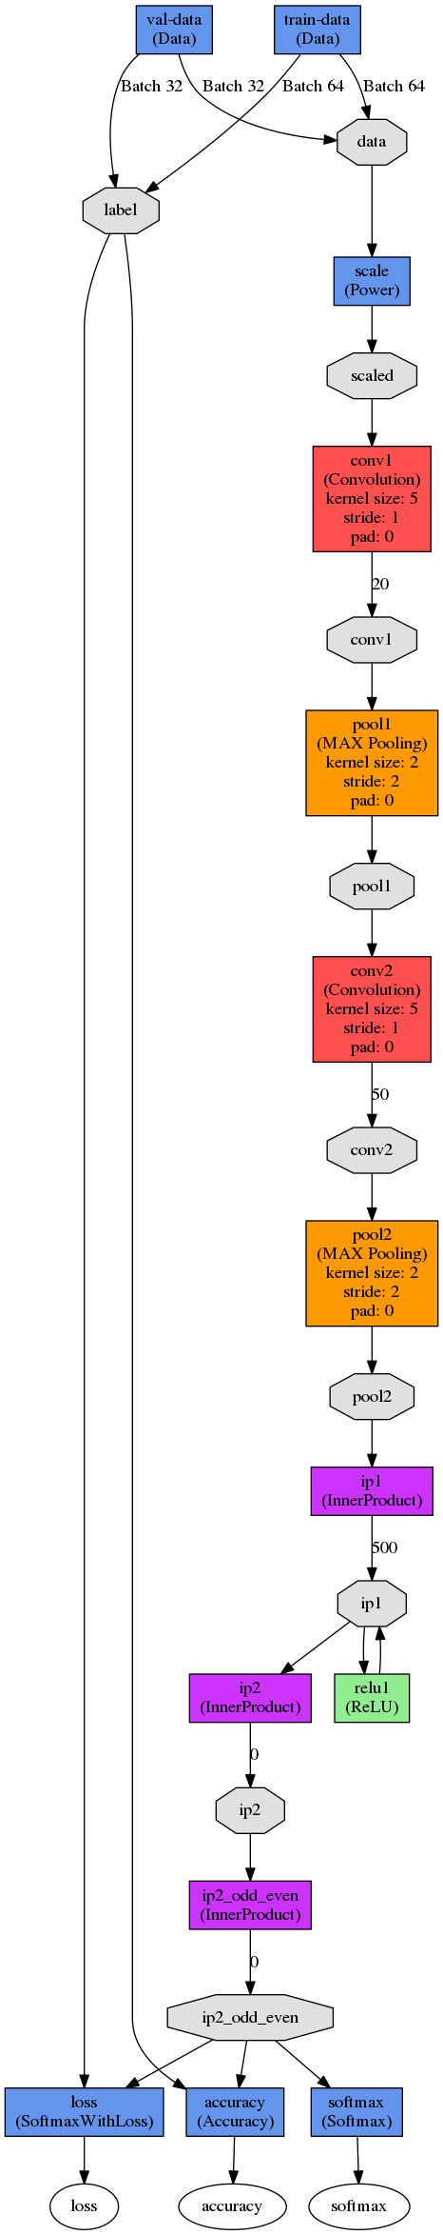

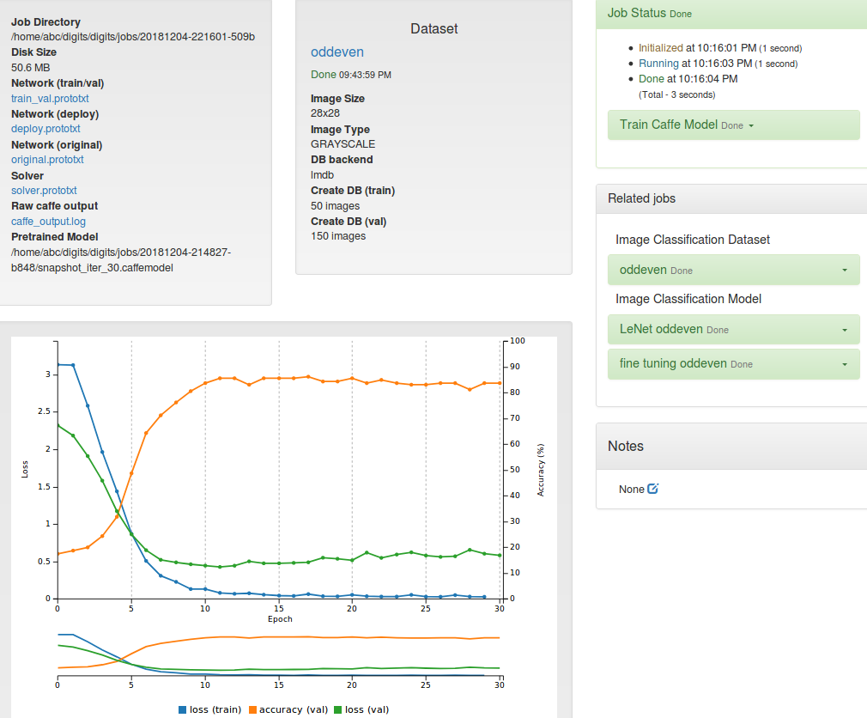

According to the plot, the loss function goes down very sharply, and the validation accuracy exceeds 80%. The less overfit should come with higher accuracy.

## 

### 3.3.10 Testing odd_even model from LeNet and model from fine-tuning

The standard LeNet model performs ok to classify the image as odd with 89.01% accuracy.

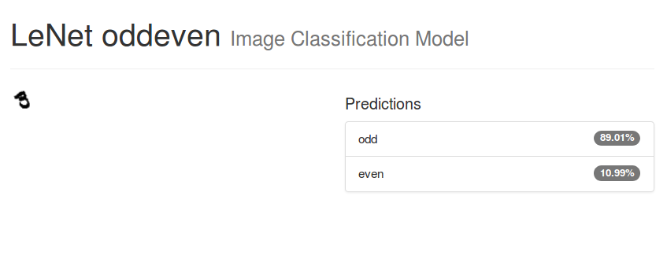

The fine-tuning model performs much better to successfully classify the image to odd with 99.51% accuracy.

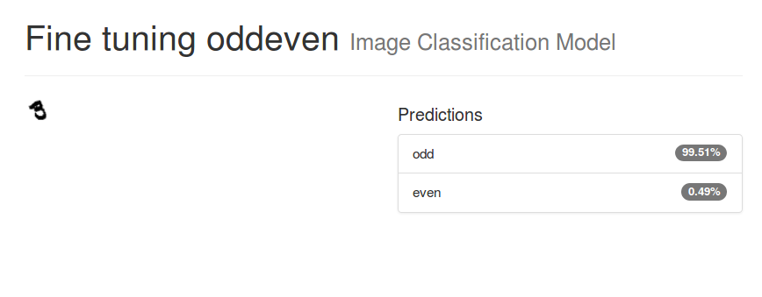

## 3.4 Encountered problems and solutions

### 3.4.1 Problems and solutions for setting up host pc

When setup the Ubuntu on the host pc, the team encountered two problems. The first one is the disk size of Ubuntu, for the first attempt, the team assigned Ubuntu with only 60GB space that is not enough for this project since the ILSVRC12 dataset is over 100 GB and there are more software and their dependencies that are needed, so it’s recommended to assign at least 150 GB to the Ubuntu and the majority of the space should be assigned to ‘home’ section. For the second attempt, the team decided to use virtual machine instead of using desktop to install the Ubuntu, however, the CUDA Toolkit requires to install NVIDIA driver that means a NVIDIA video card is required, so this project is unable to use virtual machine such as VMware workstation and Virtualbox as host pc.

### 3.4.2 Problems and solutions for flashing Jetson

In the process of flashing the Jetson, it is necessary to connect to the internet for the whole time. The team tried it on the same Wi-Fi with both the PC and the Jetson, and it didn't work. The official instruction suggests connecting the computer and the Jetson with the ethernet cable under the same router. Then select the routing connection in the pop-up network layout configuration; select the Ethernet port in the network interface, the rest remains default.

### 3.4.3 Problems and solutions for installing software

There are many different problems during the team installed CUDA Toolkit, cuDNN, NVcaffe and DIGITS. The most annoying problem is the login loop on host pc with correct password, the solution is varied that depends on what tasks have been taken right before the crash, thus the team is unable to provide a feasible solution for this issue. Other issues are easy to solve after using Google to search the specific error message.

### 3.4.4 Problems and solutions for reorganizing classes

The team reorganized 10 classes that are furniture with 10 subclasses, electronic device with 12 subclasses, fruit with 12 subclasses, vehicle with 14 subclasses, bottle with 10 subclasses, bird with 12 subclasses, cloth with 12 subclasses, sports equipment with 11 subclasses, stationery and shop with both 10 subclasses. However, this model failed to classify a laptop and after few tests on both images and camera. The team found most rectangular things are classified as stationery, digged into the images of subclass of stationery, the book should be the problem because books are actually colorful cover that would misguide the classification. The team deleted the book class, recreated the model and passed the verification.

# Chapter 4 - Test data with proof of functional design

## 4.1 Using images to test 10classesII and default GoogleNet on Jetson



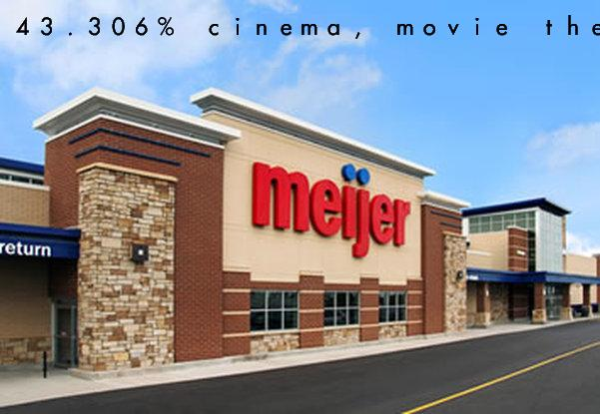

The first image is classified as the new 10classesII model as shop with 84.538% accuracy, while in the original GoogleNet-1000 it was under cinema, movie theater with 43.306% accuracy. This indicates the model 10classesII is working ok.

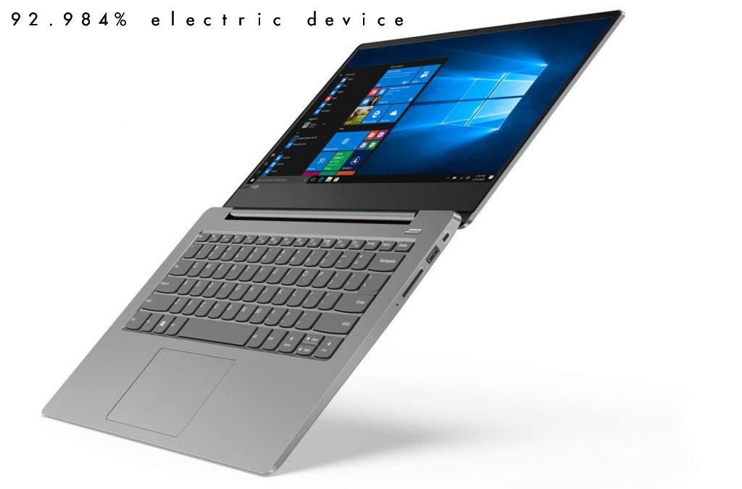



The first image is classified as the new 10classesII model as electronic device with 92.984% accuracy, while in the original GoogleNet-1000 it was under notebook, notebook computer with 81.604% accuracy. This indicates the model 10classesII is working well because the accuracy has improved.

## 4.2 Using camera to test 10classesII and default GoogleNet on Jetson

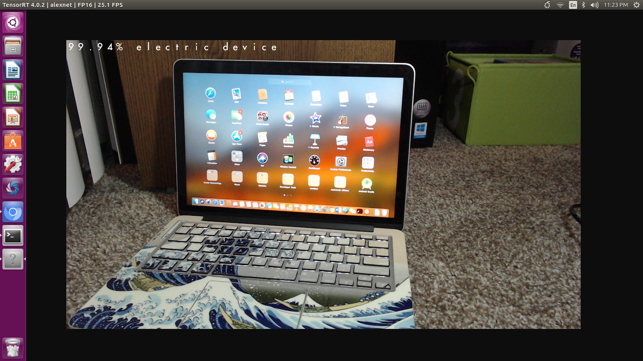

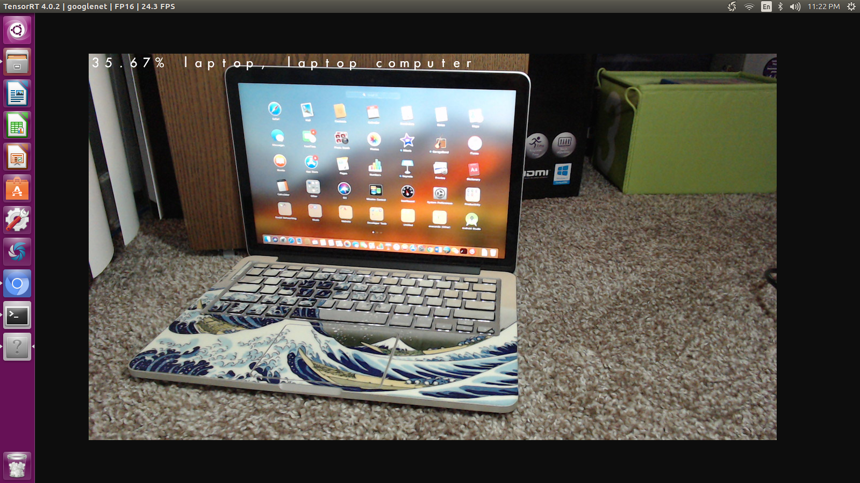

The first image is classified as the new 10classesII model as electronic device with 99.94% accuracy, while in the original GoogleNet-1000 it was under notebook, notebook computer with 35.67% accuracy . This indicates the model 10classesII is working well because the accuracy for both image and camera classification have improved.

## 4.3 Testing LeNet and fine-tuning models of MNISTMD.

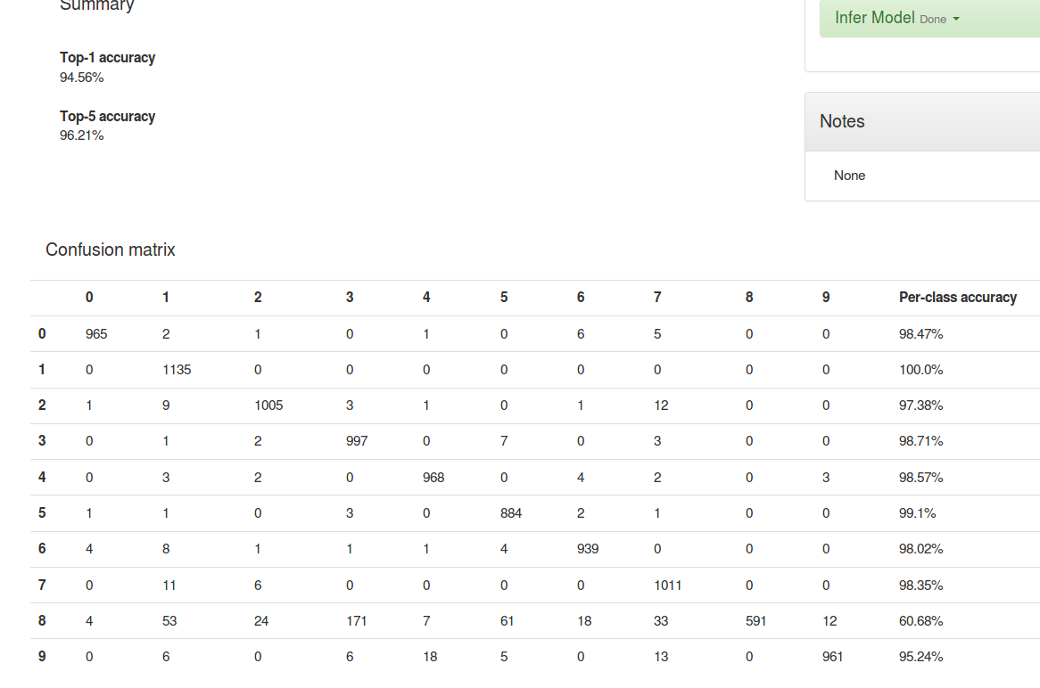

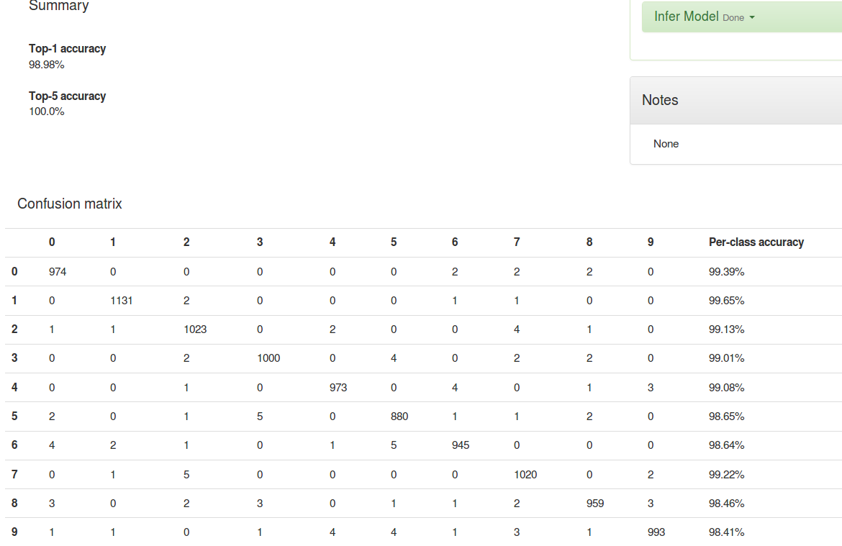

The first image is the default LeNet that this model obtains a top-1 accuracy 94.56% and a top-5 accuracy 96.21%. And the other one is the fine-tuning model that has a top-1 accuracy 96.98% and a top-5 accuracy 100.0%. The fine-tuning obtains a higher accuracy than the default LeNet thus the fine-tuning the network is working ok to successfully improve the accuracy.

## 4.4 Testing LeNet and fine-tuning models of oddeven.

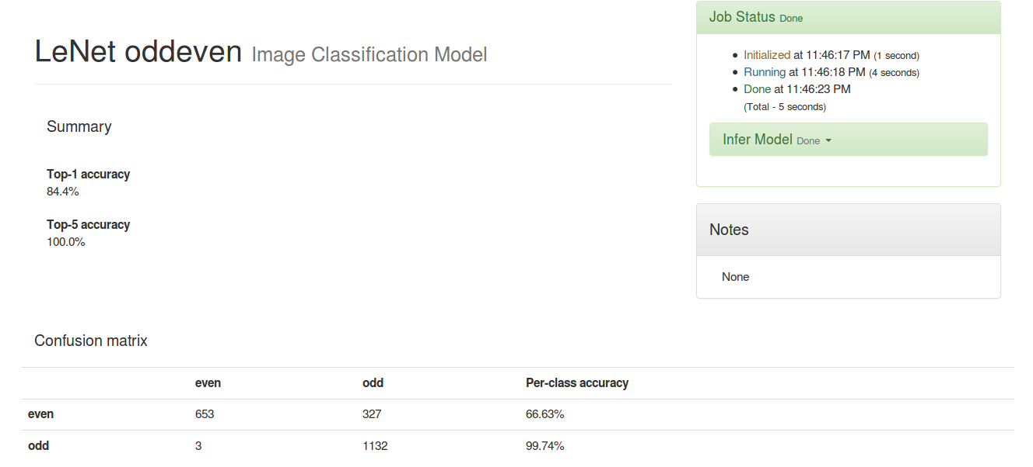

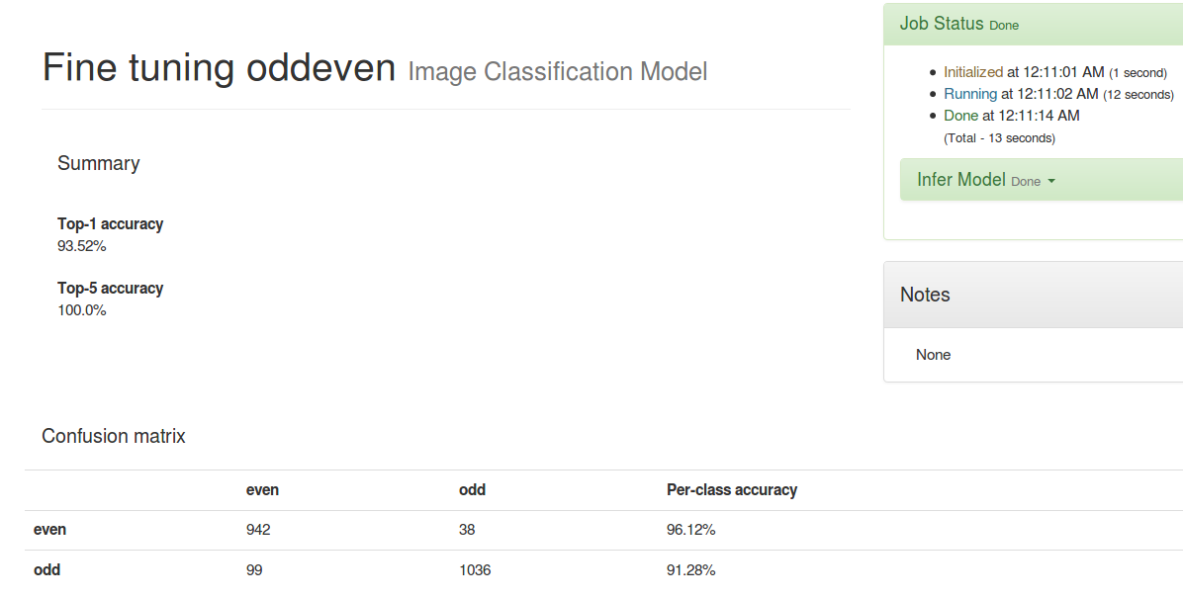

The first image is the default LeNet that this model obtains a top-1 accuracy 84.4% and a top-5 accuracy 100.0%. And the other one is the fine-tuning model that has a top-1 accuracy 93.52% and a top-5 accuracy 100.0%. The fine-tuning obtains a higher accuracy of top-1 accuracy and also the per-class accuracy of even has highly increased than the default LeNet thus the fine-tuning the network is working ok to successfully improve the accuracy.

# Chapter 5 – Summary and Conclusion

## 5.1 Summary

Team fifteen has created image classification platform, that is performed on Jetson Tx2, with highly accuracy. This platform can also detect human’s face and corresponding body movement if we implement our classification model onto another functionality.

There are many challenges throughout this project. One and most important of our challenge is the lack of people. At the beginning of this semester, the team was assigned to four people to accomplish project, which is the fewest members group among the course. Moreover, one of four members decided to take another course instead. Thus, our group members reduced to three, which may disband group. However, with the great support from and communication with our sponsor and instructors, the group can be kept as only has three members. During the rest of semester, benefits to clear work distribution, great communication, and high concentration, the team is able to finish all tasks on time.

The second challenge the team encountered is lack of guidance. Since both Jetson Tx2 and deep learning are relatively new trend topic, there is no enough instructions about how Tx2 can implement specific function. Thus, the team has to explore all operations by members. There were lots of error that the team met when built OS, install environment and install library. The team looked through operation manual and search on different forum to locate the caution of problems. Then the software engineer checked code to figure out how to adapt code to host and Jetson OS.

There is also hardware issues of building external electronic devices. For example, when the team were trying to test trained model by using camera, member found that resolution of camera is lower than the requirement of a clear classification. And the video quality is not satisfied which is full of noise. Thus, hardware engineer decided to replace the build-in camera with a high quality external camera. After he changed connection between camera and Jetson Tx2, two software engineer started to modify the code in order to make Jetson chose the desired camera as video/capture source.

## 5.2 Lessons Learned

● Communications with sponsor is the key to success

● Always have a backup version of operating system in case of the fatal crash

● Have flexible dates when determine each single period of work

● Having a controlled environment for testing is important, especially when doing image classification. And pure color background could improve the accuracy a lot

● Electrical parts are delicate, and accidentally touch it with hand could damage the equipment, thought we did not met the problem during design process

● Working as a team is faster than working as an individual, though it is a small group

● Presentations enhance not only presenting skills but requires one to fully understand the subject at hand

## 5.3 Further Improvements

Although the team has accomplished the given task, the team believes there are still further improvements that could be made to further enhance the strength in technology of the dispenser cup. In this section, the team will further explore these improvements that will be suggested for the future.

One of the improvement could be the group division. We fully understand that this maybe a very special case but within our group, all the members are Chinese. Although it will enhance the communication between group members, this could make team face challenge in some specific aspect such as documentation and presentation.

Another improvement could be equipment. According to description, each group will have a laptop to build everything on it. However, the team did not receive it and the host PC is needed to assembled by members themselves. For this deep learning topic, the next group in next semester may not face the same problem again since we will build a workable laptop as workstation for further groups. And the laptop will be provided to them at the beginning of project.

# Appendix 1 – Technical roles, responsibilities, and work accomplished.

## Team Photo

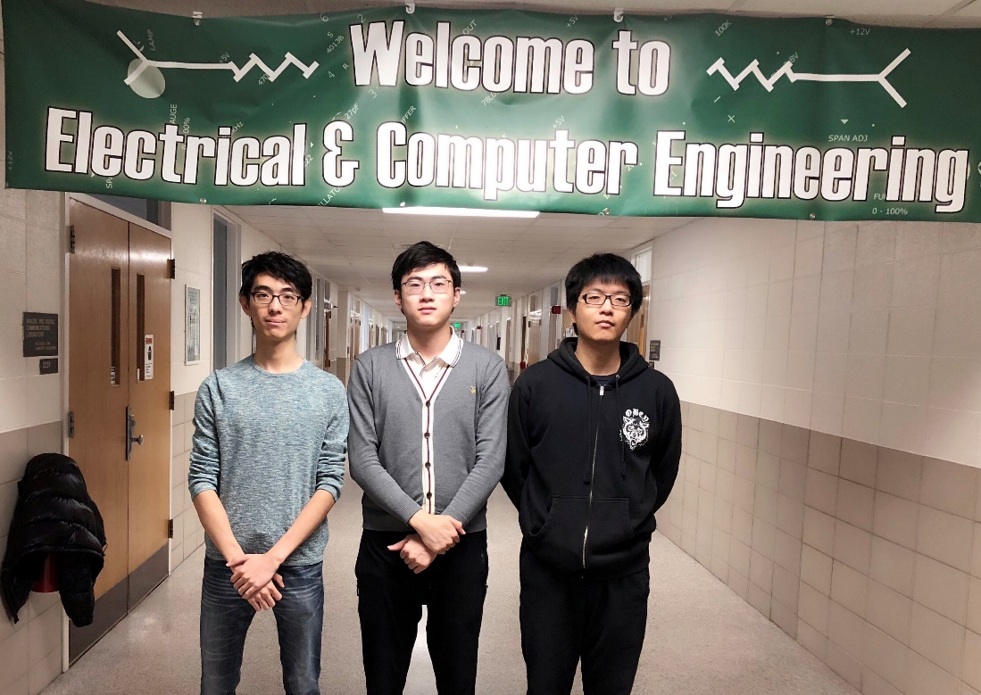

From left to right is Jiaxu Zhao, Shuotao Wang and Yu Han.

## Jiaxu Zhao

Jiaxu Zhao’s technical role is the software engineer. He is responsible for installing the host pc’s operating system, installing the latest Jetpack on the host and flashing it on the Jetson, installing CUDA Toolkit, cuDNN library, NVcaffe and DIGITS on both host pc and Jetson. Moreover, for creating datasets and models of GoogleNet on DIGITS for using ImageNet ILSVRC2012, reorganized 10 classes, MNIST and oddeven, using images to test created model of the default GoogleNet and reorganized 10 classes on DIGITS, using images and the USB camera to test the accuracy of classification with created model of the GoogleNet and reorganized 10 classes on Jetson. He is also responsible for fine-tuning network of MNIST and oddeven to create the new models based on pretrained models for testing and comparing the results in order to verify whether the fine-tuning networks are working ok. He accomplished all work with Yu Han’s help.

## Shuotao Wang

Shuotao Wang’s technical role is the hardware engineer. He is responsible for setting up the host pc for the host operating system and the TX2 module training. He is also responsible for deep learning of the TX2 module, to find out more hardware capabilities for further training. He also did some attempts on some cell phone to TX2 communications, giving user an easier way to get access to the Tx2 module. To achieve higher captured image resolution, he coordinated the module with some high-resolution cameras and justified the TX2 module have enough operation ability to process the high-resolution pictures and videos by overclocking the core.

## Yu Han

Yu Han’s technical role is the software engineer. He is responsible for installing the host pc’s operating system, installing the latest Jetpack on the host and flashing it on the Jetson, installing CUDA Toolkit, cuDNN library, NVcaffe and DIGITS on both host pc and Jetson. Moreover, for creating datasets and models of GoogleNet on DIGITS for using ImageNet ILSVRC2012, reorganized 10 classes, MNIST and oddeven, using images to test created model of the default GoogleNet and reorganized 10 classes on DIGITS, using images and the USB camera to test the accuracy of classification with created model of the GoogleNet and reorganized 10 classes on Jetson. He is also responsible for fine-tuning network of MNIST and oddeven to create the new models based on pretrained models for testing and comparing the results in order to verify whether the fine-tuning networks are working ok. He accomplished all work with Jiaxu Zhao’s help.

# Appendix 2 – Literature and website references

<https://www.nvidia.com/en-us/autonomous-machines/embedded-systems-dev-kits-modules/>

<https://developer.download.nvidia.com/embedded/L4T/r27_Release_v1.0/Docs/Jetson_X2_Developer_Kit_User_Guide.pdf?rMkjsb3Bsd4EMHyJ-pYhmYLvpBzh84uzKElRYBFKmOWGuoE3Ws3jOA2kLuOsSjruJPpLo-L8edHd8w5C90zdQJjUBeKVVKiJgWFTSKza6TkaTKFd4bYJ_GqqG6KHi16HhHAOQKhv2sC262bhWCp291NLOQjFxFkya6-8AEvfvblsxYTp3WQ3YQ>

<https://developer.nvidia.com/embedded/jetpack>

<https://developer.nvidia.com/cuda-zone>

<https://developer.nvidia.com/cudnn>

<http://caffe.berkeleyvision.org/>

<https://developer.nvidia.com/digits>

<https://docs.nvidia.com/deeplearning/digits/digits-user-guide/index.html>

<https://github.com/NVIDIA/DIGITS>

<https://github.com/dusty-nv/jetson-inference>

<https://github.com/BVLC/caffe>

<https://github.com/NVIDIA/tensorrt-inference-server>

<https://github.com/NVIDIA/cuda-samples>

<https://github.com/NVIDIA/DeepLearningExamples>

<http://www.image-net.org/>

<http://yann.lecun.com/exdb/mnist/>

<http://on-demand.gputechconf.com/gtc/2015/webinar/deep-learning-course/getting-started-with-digits.pdf>

<http://christopher5106.github.io/deep/learning/2015/09/04/Deep-learning-tutorial-on-Caffe-Technology.html>

<https://blog.csdn.net/s717597589/article/details/79117112/>

<https://blog.csdn.net/sinat_26917383/article/details/54022715>

<https://www.cnblogs.com/denny402/p/5136262.html>

<https://www.cnblogs.com/denny402/p/5136262.html>

<https://www.cnblogs.com/denny402/p/5136262.html>

<https://www.egr.msu.edu/annweb/>

# Appendix 3 – Detailed technical attachments

Parts list

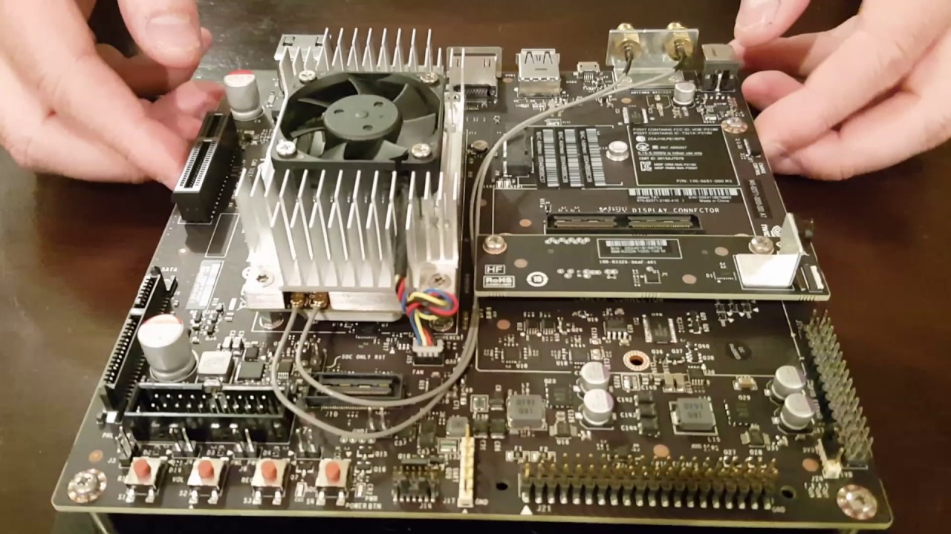

**Jetson Tx2**

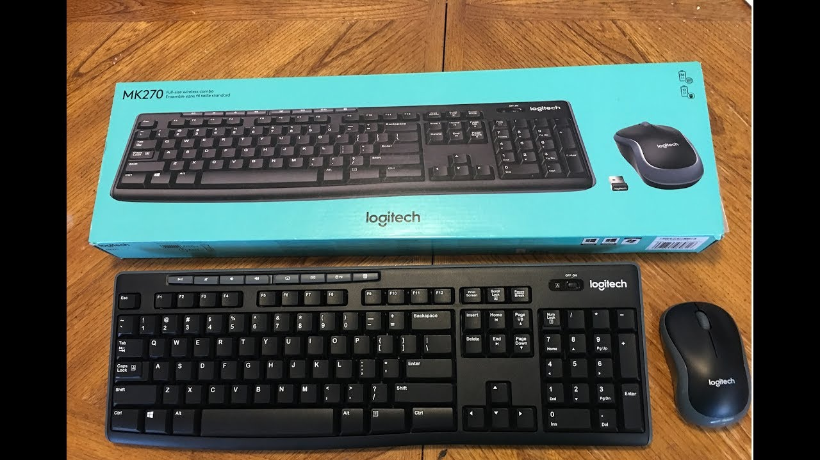

Wireless keyboard and mouse

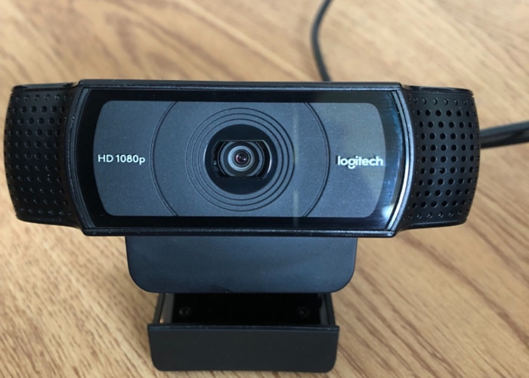

C920 camera

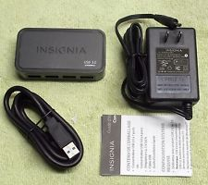

4 ports USB hub

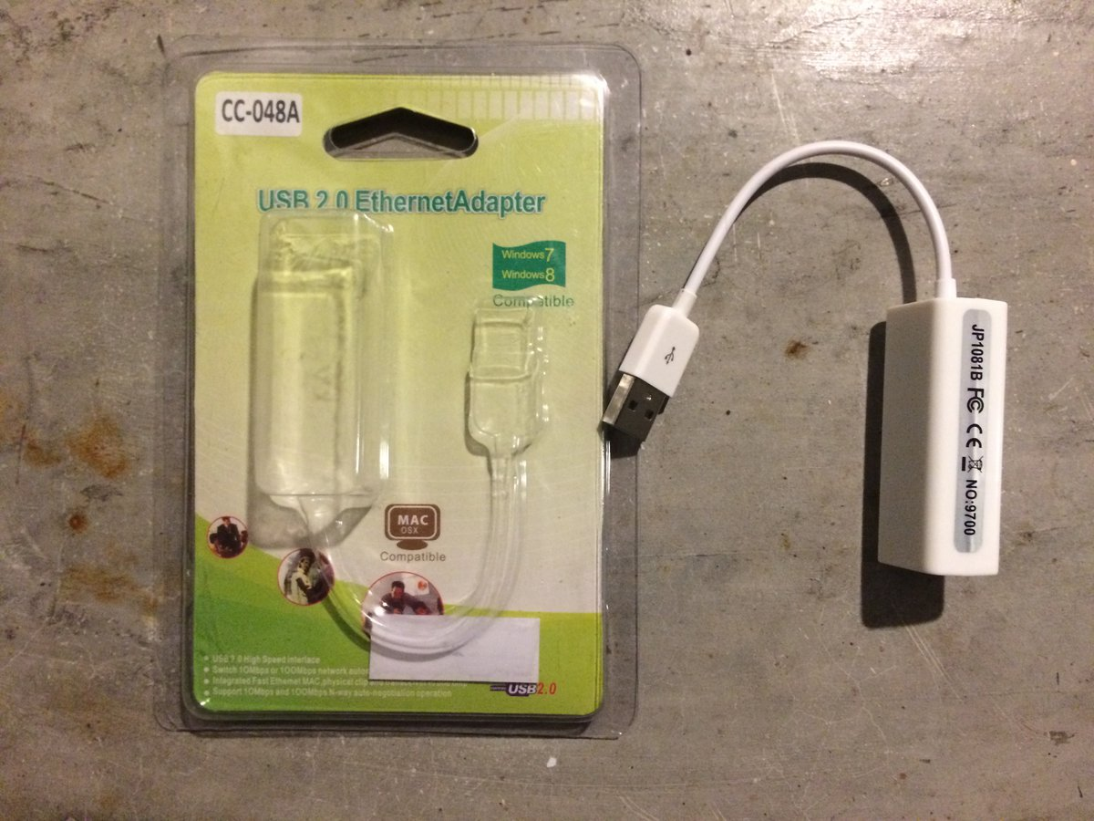

Ethernet to USB adaptor

## Source code list

### LeNet

name: "LeNet" //giving the network a name

layer { //defining a data layer

name: "mnist"

type: "Data"

transform_param {

scale: 0.00390625

}

data_param {

source: "mnist_train_lmdb"

backend: LMDB

batch_size: 64

}

top: "data"

top: "label"

}

layer { //defining the first convolution layer

name: "conv1"

type: "Convolution"

param { lr_mult: 1 }

param { lr_mult: 2 }

convolution_param {

num_output: 20

kernel_size: 5

stride: 1

weight_filler {

type: "xavier"

}

bias_filler {

type: "constant"

}

}

bottom: "data"

top: "conv1"

}

layer { //defining the first pooling layer

name: "pool1"

type: "Pooling"

pooling_param {

kernel_size: 2

stride: 2

pool: MAX

}

bottom: "conv1"

top: "pool1"

}

layer { //defining a fully connected layer

name: "ip1"

type: "InnerProduct"

param { lr_mult: 1 }

param { lr_mult: 2 }

inner_product_param {

num_output: 500

weight_filler {

type: "xavier"

}

bias_filler {

type: "constant"

}

}

bottom: "pool2"

top: "ip1"

}

layer { //defining the ReLU layer

name: "relu1"

type: "ReLU"

bottom: "ip1"

top: "ip1"

}

layer { //defining the second innerproduct layer

name: "ip2"

type: "InnerProduct"

param { lr_mult: 1 }

param { lr_mult: 2 }

inner_product_param {

num_output: 10

weight_filler {

type: "xavier"

}

bias_filler {

type: "constant"

}

}

bottom: "ip1"

top: "ip2"

}

layer { //defining the loss layer

name: "loss"

type: "SoftmaxWithLoss"

bottom: "ip2"

bottom: "label"

}

### Fine-tuning LeNet

The fine-tuning LeNet is almost the same as the default LeNet with adding an innerproduct layer named ip2_odd_even and set other layers’ learning rate to zero.

|  |
| --- |
| // defining the new innerproduct layer  layer { |
|  |

|  |
| --- |
| name: "ip2_odd_even" |
|  |

|  |
| --- |
| type: "InnerProduct" |
|  |

|  |
| --- |
| bottom: "ip2" |
|  |

|  |
| --- |
| top: "ip2_odd_even" |
|  |

|  |
| --- |
| param { |
|  |

|  |
| --- |
| lr_mult: 1.0 |
|  |

|  |
| --- |
| } |
|  |

|  |
| --- |
| param { |
|  |

|  |
| --- |
| lr_mult: 2.0 |
|  |

|  |
| --- |
| } |
|  |

|  |
| --- |
| inner_product_param { |
|  |

|  |
| --- |
| weight_filler { |
|  |

|  |
| --- |
| type: "xavier" |
|  |

|  |
| --- |
| } |
|  |

|  |
| --- |
| bias_filler { |
|  |

|  |
| --- |
| type: "constant" |
|  |

|  |
| --- |
| } |
|  |

|  |
| --- |
| } |
|  |

}